**Columbia County Community Healthcare Consortium, Inc.**

**Minutes of the Governance Committee meeting of June 27, 2018**

**Attending**: Robin Andrews (Chair), Jeff Rovitz, Scott Thomas, Laurie Scott and John Thompson (by phone). Staff: Claire Parde

**Discussion Summary**:

**Review of full Board assessment**

The Committee reviewed the compilation of responses to the Board assessment that were compiled by Robin. There were 18 respondents. Generally, the responses were favorable, with only one or two board members who consistently offered unfavorable responses.

Many respondents selected the “maybe/not sure” category. It was noted that while this was positioned in the middle of all five possible responses, it is not a “neutral” selection, per se. It was suggested that future versions of the assessment tool be revised to add a “neutral” option and reposition the “maybe/not sure” category as a 6th possible response option.

It was also noted that the responses to Q33, an open-ended question, were skimpy, perhaps as a function of its position on the page. When the instrument is revised, this question should be moved to the following page in order to allow respondents more space to reply.

The Committee expressed an interest in seeing the results of the last board assessment in October 2015. These will be reviewed at the next meeting.

The Committee noted that engagement is an area of concern. In order to better engage board members, it was agreed that Robin and Claire would meet with each member or a small group of members, in turn, with the goal of having one meeting per month.

There will also be activities designed to promote fellowship among board members. These include brief “icebreakers” at the outset of board meetings, such as “Two truths and a Lie.”

Finally, the group agreed that off-site board meetings should continue to occur. Claire and Ashling will propose a schedule for the remainder of 2018 and whole of 2019.

**Review of the new board member recruitment and onboarding process**

Claire shared a document that outlines the New Board Member Recruitment and Onboarding Process (see attached). The following changes to the document were recommended:

* After a candidate for board membership has completed the Prospective Board Member Profile and it has been reviewed by the Committee, the candidate will be invited to meet with the Committee. This will be the last step before the Committee makes a determination to nominate the individual for board membership.
* RE: Committee Work and Assignments, it was agreed that new board members will be “invited” to attend meetings of any committee that interests them at any time during their first *year* of service.

Claire shared a sample New Board Member Recruitment Packet that contains all the documents that are provided to a board candidate.

Thereafter, she shared a sample New Board Member Onboarding Packet, which contains all the documents that are provided to a member once elected.

As part of the onboarding process, it was suggested that new board members tour the Consortium’s office and meet with each program team. Whenever these are scheduled, existing board members will also be invited to attend.

**Review role of mentor and how that might be enhanced**

The role of board mentors was discussed. While it was agreed that board mentors are a good idea, their potential has not been fully realized as yet. It was suggested that the Executive Director and the Board Mentor engage new board members in structured discussions every 3 to 4 months in the new member’s first year of service.

**Update on Art Proper**

Robin reported that Art Proper has taken a new position as Administrator at the Troy Center. As he is no longer affiliated with the Fireman’s Home, there should be an action at the Board level to change his designation to “non-designated.” Happily, Art would like to continue on the Board, Personnel and Executive Committees.

**Other**

* Robin reported that she asked Linda Tripp to serve as the Chair of the Governance Committee immediately prior to the meeting and is awaiting her reply.
* The Committee requested that Program Managers provide periodic program updates to the Board of no more than 10 minutes.
* John Thompson requested that a glossary of frequently used terms be compiled and distributed. Claire will follow up.

**Next Meeting: Wednesday, September 26, 2018 at 1:00 pm**

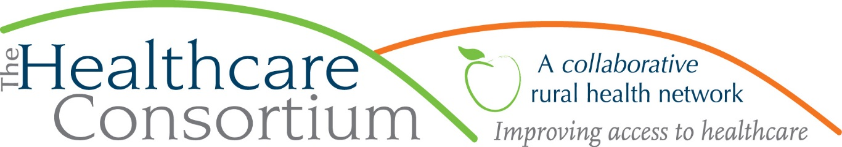

**NEW BOARD MEMBER RECRUITMENT/ONBOARDING PROCESS**

**Discuss candidate**

Always discuss potential Board member candidate(s) in Committee before making contact. If a decision is made to pursue a candidate, determine the appropriate person to reach out to the individual(s). Typically, this would be the Governance Committee chair or her/his designee

**Reach out to prospective member to gauge interest**

If the candidate is interested, the Governance Chair and Executive Director should meet with the prospective member to educate him/her about the Healthcare Consortium, including its history, structure, function and governance model. This discussion should also touch on the Role and Responsibilities of a Board member, including Committee participation, and the Role of Board members in the Rural Health Network (see handouts).

**Collect initial paperwork**

If the candidate continues to be interested in Board service, ask him/her to complete the following:

* Prospective Board Member Profile
* Disclosure of Financial Interests Form
* Medicaid Exclusion Checklist Form

**Review meeting and paperwork in Committee**

The meeting and paperwork should be reviewed with the entire Governance Committee, which shall make a determination about whether the candidate shall be nominated to the Board

**Nominate and elect**

If approved for nomination by Governance, move to elect the candidate at next appropriate meeting of the Entire Board. Once elected, schedule new Board member orientation; send new Board Member packet prior to orientation (see attached New Board Member Packet Checklist)

**Assign Board mentor**

Assign the new member a Board Mentor (Note: the Role of Mentor must be further fleshed out)

**Explore Committee Work and Make Assignment(s)**

In their first six months, new Board members should be encouraged to attend at least one meeting of each committee (with the exception of Executive and any other committee for which they may not be eligible as a function of non-Independence). Thereafter, and in consultation with the new member and Governance Chair, the President should appoint the member to a Committee(s)