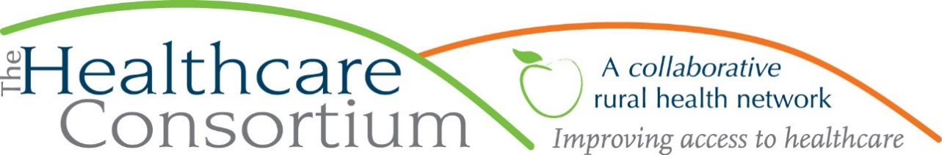

**Executive Director’s Report to the Board**

**April 1, 2020**

**COVID-19 Response**

As you know from previous communications, the Healthcare Consortium, like all our network members and other partners, has been formulating a response to the COVID-19 outbreak “on the fly,” making adjustments as the situation unfolds. Our earliest efforts entailed a communication to staff in the week of March 9th about precautionary measures such as personal and workplace hygiene and “light” social distancing and also a reminder for staff about utilizing accrued time off when ill. By the following Monday, March 16th, we made the first modifications to our service delivery, screening clients prior to scheduling in-person appointments, and suspending all off-site service delivery and public education and outreach activities. By Wednesday, we began to prepare to comply with the Governor’s Executive Order to reduce in-office personnel by 50% by Friday, March 20th. The following day, that number was increased to 75% and by Friday, it was further increased to 100%, with an expectation of compliance by Sunday, March 22nd at 8:00 p.m.

An enormous effort was made to transfer equipment, materials and supplies, program phone lines, post signage, and do numerous other things in order to fully comply with this latest order. By Monday, March 23rd, all the staff that we deemed eligible to work from home were doing so. For the time being, all programs and services, continue to function. This includes Transportation, although it is greatly diminished, as PROS at MHA has been suspended and also the majority of patients and providers are rescheduling non-urgent appointments. We do, however, continue to transport 18 individuals to and from life-sustaining dialysis treatments 2-3 times per week. We are extremely grateful to our dedicated and courageous drivers for continuing to deliver this critically important service at this difficult time.

I am saddened to report that two staff members who we could not accommodate under the current conditions were advised on Friday, March 20th that they would be laid off effective Friday, April 3rd; both are still in our employ and using PTO during the two-week notice period. They will be paid out for all remaining accrued time in their accounts when they receive their last paycheck. We expect that both will be eligible for unemployment insurance benefits during their layoff period. While it is impossible to predict when the Executive Order will be lifted and our normal operations will resume, we hope that when that happens, both staff members will return.

For those staff now working from home, there were some early challenges related to technology. However, much of that seemed to be resolved by the end of last week and this week is already seeming to settle into something much more routine. Program Team leaders are in constant communication with staff via phone and email throughout the week; they are also scheduling once weekly team meetings via Zoom. We have implemented a system for staff to outline their weekly schedule and goals, capture their activities in a daily log, and generally to stay connected to each other, for accountability, guidance and support. So far so good.

Throughout, we have been educating ourselves about the situation and the responses at the county, state and federal levels, including emerging legislation. In this, we have relied heavily on our labor law firm, Bond, Schoeneck and King, which has been producing weekly webinars as well as bulletins on their website.

**Current Program Updates**

**Rural Health Network Program Update**

As previously reported, the NYS Legislature made $18,886 available to the RHN Program for the period of April 1, 2019 through March 31, 2020 through a contract with the New York State Association for Rural Health. We previously expensed $10,000 on transportation program expenses and have expended the remaining dollars on an agency-wide compensation study and additional transportation program expenses. The final voucher will be submitted by April 10th.

ALERT: The Governor’s Executive Budget proposed to cut the Rural Health Network Development Program by 30%. NYSARH and others have conducted advocacy around this issue, but much of that work was interrupted by the COVID-19 outbreak. There is considerable trepidation about the state budget.

**Transportation Program Update**

As previously noted, the New York State Department of Transportation (NYSDOT) released the Request for Applications for 5310 funds. The Consortium applied on March 13th to purchase a new wheelchair accessible vehicle and for some modest operating assistance.

**ICAN Program Update**

On March 13th, the Healthy Capital District Initiative visited the Healthcare Consortium’s ICAN team (including myself, Lisa Thomas, Lynda Scheer and Kelly McGiffert) to discuss performance on our current subcontract for ICAN services. It was a productive visit.

**Personnel Updates**

* Kristy Tillman started on March 9th as the Community Engagement Coordinator for the Tobacco Free Action Program.
* A second candidate for the same position seemed suitable for the Program Development position that I have been contemplating and we were scheduled for an interview via video call this week. However, I will not hire until the implications of the State Budget and the Coronavirus are fully known.

**Board and Community Relations**

**Past activities and events**

* On March 11th, the program managers met with Darcy Connor to determine how our organizations may work more closely together
* On March 13th, Jeff Rovitz and I met with the President and Provost of CGCC to discuss opportunities to collaborate on workforce development
* On March 17th, I was on Randall Martin’s radio show on WGXC
* On March 26th, I participated in Congressman Delgado’s Healthcare Advisory Committee
* On March 27th, I was a panelist on Congressman Delgado’s Tele Town Hall

**Upcoming Activities and Events**

* On 4/2, I will participate in Congressman Delgado’s Healthcare Advisory Committee
* On 4/19, the transportation grantees of the Foundation for Community Health will meet via videocall