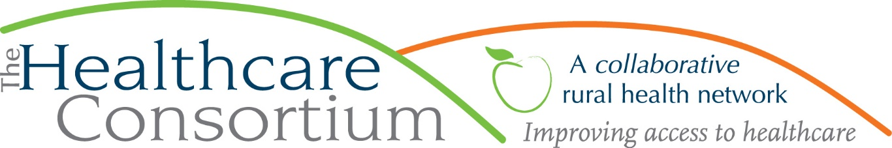

**Executive Director’s Report to the Board, October 6, 2021**

**Resource Management**

**New York State Contracts**

* TOB—The budget for Year Two beginning on July 1, 2020 and ending June 30, 2021 for the **Tobacco Control** contract with NYSDOH was finally approved, and the outstanding voucher from May was paid; we continue to await payment on the June voucher. Additionally, we have now been asked to submit the budget and work plan for the current contract year that began on July 1, 2021 and ends June 30, 2022. This will be complete by October 12th.
* NAV—The budget and work plan for the current year of the **Navigator Program** contract with NYSDOH, which began on August 1, 2021 and ends July 31, 2022, has been approved. In the next payroll cycle, we will affect the annual wage increases for contract staff, including back pay to the contract start date.
* RHN—As of October 1st, we will have entered the fourth and final quarter of the contract for the **Rural Health Network Development Program.** We anticipate being asked to submit a budget and workplan for the next contract year, starting January 1, later this fall.We also anticipate another influx of fundsfrom the legislative appropriation to rural health networks that is administered by NYSARH. If the allocation is similar to last year, this amount should be roughly $18K.

**Foundation Contracts**

* Since our last report, we executed the contract with the Foundation for Community Health for General Operating Support in the amount of $100,000. The term of the contract is, we were surprised to find, July 1, 2021 to June 30, 2022, and we received the funds in late August. Provided that we continue to meet the terms and conditions of the agreement, the grant is conditionally approved for two additional contract years starting July 1 and ending June 30th.

**Resource Development**

As we do yearly, in early September we applied for funding to support CARTS, our non-emergency medical transportation program, from the Foundation for Community Health for the 12-month period starting January 1st. We anticipate hearing their determination about our request shortly.

**Personnel Management**

Our new staff members have all passed their probationary period and have been allocated vacation and personal leave accordingly. Elaine Allen’s return from her leave of absence in late August fully restored our team (zero vacancies, no absences) but sadly, that did not last long: Mahfuz Rahman, a Navigator, tendered his resignation, in order to work in the billing office at CMH. We will seek to fill this position because we are contractually obligated to do, but not with great haste, as the current work demands on the Navigator Team are very light.

**Board and Community Relations**

* On behalf of a small group of providers who were responsible for updating the **Addiction Epidemic Response Plan**, I presented to the Columbia County Board of Supervisors on August 11th
* I’ve joined and started to participate in meetings of the **Fatality Review Board** that will review deaths related to Behavioral Health (overdoses, other substance use, completed suicides etc.) with the goal of identifying gaps, challenges and barriers within our system
* I continue to convene and facilitate meetings of the **Southern Hub Behavioral Health Workgroup**, which meets once monthly
* I am now part of the **Advisory Committee of the Everhome Columbia Project**, which aims to marry care coordination and in-home technology to help seniors live safely and independently at home
* I continue my work with the following committees/coalitions/workgroups:
* Community Services Board and its Alcohol and Substance Abuse Committee, which I chair
* the Columbia-Greene Addiction Coalition
* the Steering Committees of the HEALing Communities Studies in both Columbia and Greene Counties
* The Community Advisory Committee of the NYS Health Foundation
* Congressman Antonio Delgado’s Healthcare Advisory Committee
* I also continue to remain active on the following boards:
* Columbia Memorial Health
* Twin County Recovery Services
* New York State Association for Rural Health
* Catskill-Hudson Area Health Education Center
* Last but certainly not least, I met with Toni Carroll, the new Executive Director at the Greene County Rural Health Network. I am very excited about the prospect of working more closely with the GCRHN and have already engaged her in the work we do on behalf of Columbia Memorial Hospital and in partnership with the Columbia County Department of Health and Greene County Public Health to conduct the Community Health Needs Assessment. Toni was good enough to utilize her website, social media pages, and extensive email distribution list to promote a community survey, and Greene County respondents already surpass those from any county in the Capital Region! Toni and I are scheduled to meet again on October 8th to discuss supporting medical transportation in Greene County and how CARTS might support her efforts. In all, I believe this leadership change presents great new opportunities to our agencies for aligning and supporting each other’s work, and I’m **super excited** about it!

**Upcoming Board and Committee meeting dates**

* 10/27 Governance Committee 1:00 pm
* 11/3 Executive Committee 9:00 am
* 11/23 Budget and Finance Committee 3:00 pm
* 12/1 Board of Directors 2:30 pm