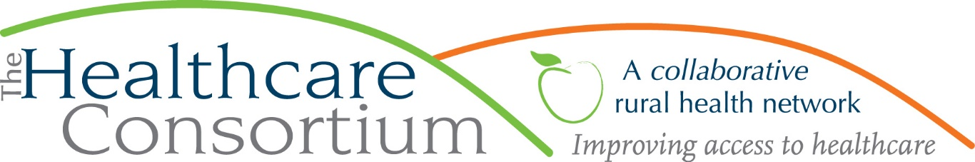

**Executive Director’s Report to the Board**

**October 5, 2022**

**Fiscal Management**

**New York State Contracts**

* TOB—The contract for our **Tobacco Control Program** is paid through July. The August voucher has been submitted. The budget and work plan for Year 4, starting July 1, 2022, have also been submitted and we are now awaiting approval, which we anticipate will take several weeks. In the meantime, NYSDOH permits us to voucher for expenses using the prior contract year’s budget.
* NAV—NYSDOH has reimbursed expenses incurred by the **Navigator Program** contract through July. The budget and work plan for Year 4, starting August 1, 2022, have been submitted and we are now awaiting approval, which we anticipate will take several weeks. In the meantime, NYSDOH does NOT permit us to voucher for expenses until the new budget year
* RHNDP—We have been reimbursed for all second quarter expenses associated with the **Rural Health Network Development Program.**
* **MWBE**—All three NYS contracts have spending targets related to Minority and Women Owned Business Enterprises (MWBEs). After at least two+ years of total neglect, the NYS Contract System appears to be “catching up” on its backlog all at once, as evidenced by multiple messages per day (one for each quarter of each year for each contract dating back to 2019). Reporting and preparing waiver requests is laborious, time-consuming, and deeply frustrating.

***Takeaway:***  ***We are patiently awaiting NYSDOH approval of our contract budgets.***

**Other Contracts**

* FCH—We have received the second $100,000 installment from the Foundation for Community Health’s three-year commitment to provide General Operating Support.

**Other Project Work**

* I have continued to work on the Transportation Coordination Plan with a committee led by Supervisor Michael Chameides
* I have continued my work with the small group of network members focused on services and supports for Columbia County’s migrant/immigrant residents
* I have joined a small group of Community Services Board members who are developing next year’s Local Services Plan
* I continue to work on the Community Health Improvement Plan/Community Services Plan with colleagues from both health departments

**Personnel Management**

* As previously reported, we had been advertising for two part-time Public Health Americorps Members—one as a Health Educator and another as a Transportation Program Assistant. After some thought, we decided that we would not attempt to host the Public Health Educator due to lack of supervisory capacity; we continue to advertise for the Transportation Program Assistant, but have not received any applications.
* We eagerly await the return of our colleague, Elaine Allen, from Family Leave later this month.

**Board and Community Relations**

* On August 11th, I attended the Columbia County Chamber of Commerce’s Business After Hours event
* On September 12th, I met with Kelly Lane from the Capital Behavioral Health Network to discuss how we might operationalize a contract for transportation services to individuals with Substance Use Disorder
* On September 16th, Jim, Marcy, and I met with several members of the team from the Greene County Office for the Aging to discuss our contract for transportation services. It was a great meeting.
* On September 21st, I attended the training hosted by the Long Term Care Council on Caring for Older LGBTQIA+ Adults.
* On September 23rd, I facilitated a Q&A for Commissioner of Health, Dr. Bassett, and introduced Lieutenant Governor Antonio Delgado at the Rural Health Symposium organized by the New York State Association for Rural Health (NYSARH)
* On September 28th, I met with Mackenzie Shorter from the American Heart Association to discuss that agency’s efforts to situate an Americorps member at an agency in Hudson, and subsequently facilitated a few introductions for her
* On September 28th, I attended the Community Services Board’s annual luncheon and awards ceremony, where Beth Schuster and Jeff Rovitz were honored
* On September 29th, I met with the Deputy Secretary for Health and the Chief Health Informatics Officer from Governor Hochul’s Office to advocate for funding to NY’s rural health programs
* On September 29th through October 1st, I attended the annual conference hosted by HANYS in Syracuse
* On October 3rd, I facilitated a meeting of migrant/immigrant stakeholders at CGCC
* On October 4th, I met with the members of the NY Health Foundation’s Food Security Team, at their request, to discuss the intersection between transportation programs and food access

**Upcoming Board and Committee Meeting Dates**

10/26 Governance Committee 1:00 pm

11/2 Executive Committee 9:00 am

11/22 Budget and Finance Committee 3:00 pm

12/7 Board of Directors 2:30 pm