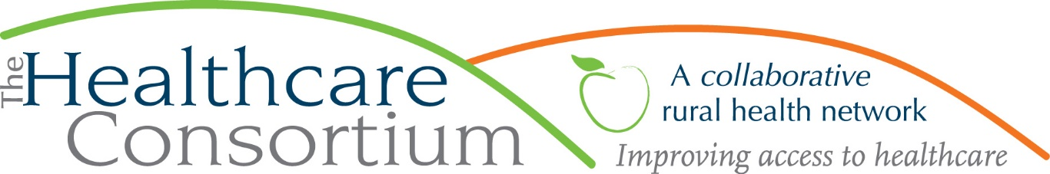

**Executive Director’s Report to the Board**

**April 6, 2022**

**Fiscal Management**

**New York State Contracts**

* TOB—The Year 3 budget and work plan for the **Tobacco Control Program** that began on July 1, 2021 has FINALLY been approved. That allowed us to voucher using the new budget, and to issue roughly $30,000 for media expenses that we had delayed paying until the contract was approved. It also allowed us to provide back pay to the Program Director for an upward adjustment to her salary that was effective on July 1st. In other TOB news, this division at NYSDOH has a particular and oddly cumbersome process for budget modifications; they require that we request permission from our contract manager to submit, which we did over three weeks ago, and now find that we are awaiting a particular form from their fiscal unit. The other units at DOH with which we deal do not function in this way.
* NAV—NYSDOH has reimbursed expenses incurred by the **Navigator Program** contract through January; we recently submitted a reimbursement request for February.
* RHN—We submitted a budget and work plan for the 2022 grant year (January 1-December 31, 2022), which has been approved, and will be submitting a voucher for first quarter expenses by month’s end.
* ***Takeaway:***  ***We can finally report that, after significant and inexplicable delays on the part of NYSDOH, the budgets and work plans for all current year contracts have been approved.***

**Other Contracts**

* Our contract with the Greene County Public Health Department for the Consortium to represent that agency in collaborative community health improvement planning activities, has been executed and the work is underway. The Consortium, in turn, has subcontracted with the Greene County Rural Health Network to support these activities.
* Our contract with Coarc for Strategic Planning services has been amended to extend the project period through September 2022.
* Our contract with the Columbia County Office for the Aging (CCOFA) for MIPPA services commenced on April 1st and will continue for 5 months, through August 31, 2022.
* Our contract with the CCOFA for NY Connects expired on March 31, 2022. As is typical, we expect to receive a request from the New York State Office for the Aging (NYSOFA) to submit the budget for the current contract year in May or June, with approval expected in August.
* Our contract with the New York State Association in the amount of $29,668 has been vouchered and reimbursed in full.
* Our contract with the Columbia County Department of Health in the amount of $231,526 has been vouchered and reimbursed in full.
* We are currently pursuing a contract with Greene County to provide transportation services to clients of the Greene County Department of Human Services.

**Loan Status**

In February, we issued a loan of $100,000 to the New York State Association for Rural Health. We anticipate that loan will be repaid in full later this spring or very early summer.

**Further Investment**

In view of our strong cash position, we added another $100,000 to the investment account in March.

**Funding opportunities**

We plan to submit an application to the NY State of Rural Health (SORH) for Technical Assistance funds. The maximum award amount is $10,000, and we will apply for nearly that amount to offset the expense associated with our contract with M.S. Hall & Associates (see Strategic Planning note below).

**Advocacy**

As previously reported, the bulk of our advocacy at the state level occurred in January and February, with just a bit—a meeting with Senator Gallivan on Monday, March 7th—spilling into March. Since then, the focus of my advocacy work has been at the federal level, including a recent meeting with Congressman Antonio Delgado earlier this week.

**Planning**

The work of the Strategic Design Workgroup and our contracted consultants from M.S. Hall & Associates began with a kickoff meeting on Friday, March 18th; the group will continue to meet weekly for a period of 6 weeks. Staff also compiled and submitted a good deal of background documentation, by request.

**Personnel Management**

In the past 6 months, we have added the following people to our team:

1. Driver – Rick Hawes, 12/2/21
2. Driver – Ed Segur, 12/15/21
3. Receptionist –Mary Anuska, 3/15/22
4. Driver – Dave Stockley, 3/23/22
5. Navigator – Victoria Juliano, 3/28/22
6. Receptionist – Mary Moores, 4/5/22

In the month of April, we will be celebrating the 10-year anniversaries of Fiscal Director, John Ray, and Navigator, Doreen Rodriguez. In May or June we will be seeking to have a half-day staff retreat at Olana.

**Upcoming Board and Committee Meeting Dates**

PLEASE NOTE: Starting with our next Board of Directors meeting on June 1st, **board meetings will take place in the Saland Forum, Room 614, at Columbia Greene Community College**. This room provides adequate space for social distancing, as desired, and is well-equipped to support remote participation for anyone who needs/wants to “Zoom in.” For the sake of convenience, committee meetings will continue to be conducted via Zoom.

5/4 Executive Committee 9:00 am

5/4 Corporate Compliance Committee 10:00 am

5/24 Budget and Finance Committee 3:00 pm

6/1 Board of Directors 2:30 pm