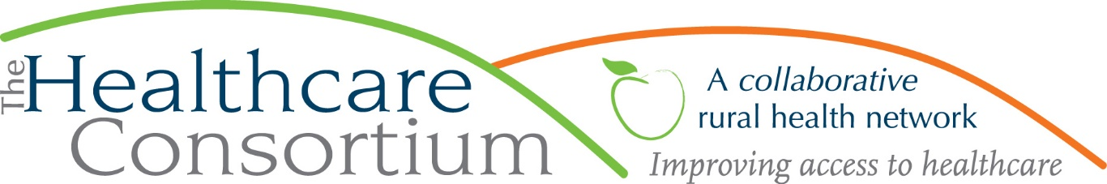

**Executive Director’s Report to the Board**

**June 1, 2022**

**Fiscal Management**

**New York State Contracts**

* TOB—The contract for our **Tobacco Control Program** is paid through March. Also, the budget modification request we submitted has been approved.
* NAV—NYSDOH has reimbursed expenses incurred by the **Navigator Program** contract through March. RHNDP—We have been reimbursed for all first quarter expenses associated with the **Rural Health Network Development Program.**
* ***Takeaway:***  ***All NYSDOH contract budgets are reimbursing expenses timely.***

**Other Contracts**

* NYC--We recently received an invitation from NYSOFA to submit a budget for the current **New York Connects** contract period, which began on April 1. The award amount is unchanged from previous years.
* RHN TA—My application to the NY State of Rural Health (SORH) was successful, and we have been awarded **Rural Health Network Technical Assistance** funds in the amount of $9,750 to offset the expense associated with our contract with M.S. Hall & Associates.
* GCDHS—Our contract with Greene County to provide transportation services to the clients of the **Greene County Department of Human Services** has been reviewed and approved by the County Attorney and currently making its way through the legislative process. The expected start to the contract term is July 1.
* FCH--In the next two weeks, we will be focused on reporting to the **Foundation for Community Health** about the past General Operating Support award, including a planned meeting with the contract manager on June 15th. In July, we will also be engaged in planning for the next award, expected in July.

**Planning and Other Project Work**

* The work of the Strategic Design Workgroup and our contracted consultants from M.S. Hall & Associates continues, with meetings scheduled through June 17th.
* In collaboration with key partners at CCDSS and CCDOH, we have embarked on an effort to better understand the needs of and services for our immigrant population, including both migrant seasonal workers, typically originating from Latin American countries and Jamaica, as well as immigrant workers who reside in the County year-round. Although the group already has some awareness of this, we realized that we needed to make a more systematic inquiry with a larger group of helping organizations. Toward that end, we developed and disseminated an email survey to key stakeholder groups and are collecting the responses now. After we complete this survey, it is our intention to convene a larger group of stakeholders with whom we will share the findings, identify any gaps in services, and strategize about how to fill them.
* I continue to meet regularly with the Columbia-Greene Planning Partners—that is, Greene County Public Health, the Columbia County Department of Health, and the Columbia Memorial Health—to complete the Community Health Needs Assessment and initiate the Community Health Improvement Plan.
* As part of my work as a member of the Columbia County Community Services Board and as a Chair of its Alcohol and Substance Abuse Subcommittee, Melissa Scheriff and I have been engaged with CGCC, including President Carlee Drummer and Dean Casey O’Brien, to explore education and training options for the health and human service workforce
* Jim Funk and I continue to be actively engaged in the Columbia County Transportation Committee and its current effort, ably led by Supervisor Michael Chameides, to review and revise the Countywide Transportation Coordination Plan. This effort considers all public and private transportation options in the county, identifies gaps, and considers ways to address the unmet need. A current, coherent Coordination Plan is an important point of reference for anyone seeking state or federal transportation funding. Most recently, I worked with Commissioner Bob Gibson to develop a questionnaire for area agencies about their transportation programming and capacity.
* I continue to facilitate a strategic planning project for Coarc, with a full-day retreat for Directors and Leadership staff on May 24th
* I continue to facilitate the Southern Hub Behavioral Health Workgroup, which meets monthly

**Personnel Management**

* We have submitted brief positions descriptions for two part-time Public Health Americorps Members to the Rural Health Network of South Central New York (RHNSCNY). We are hopeful that we will be included in this opportunity and are awaiting further guidance.
* On Friday, May 27th, we had a nearly full-day staff retreat at Olana, including house tours and a potluck meal. This was probably one of the nicest staff events we have had during my tenure, and I received some very nice notes and comments from staff communicating their appreciation for the experience.

**Community Relations**

* On May 11th, I attended the Healing Hearts Breakfast hosted by the Addictions Care Centers of Albany
* On May 18th, I participated in the semiannual meeting of the NYHealth’s Community Advisory Committee
* On May 20th, I met at length with Supervisor Donal Collins, Chair of the Health and Human Services Committee of the Columbia County Board of Supervisors

**Upcoming Board and Committee Meeting Dates**

7/6 Executive Committee 9:00 am

7/26 Budget and Finance 3:00 pm

7/27 Governance 1:00 pm

8/3 Board of Directors 2:30 pm

**PLEASE NOTE:** Board meetings will take place in the Saland Forum, Room 614, at Columbia Greene Community College. This room provides adequate space for social distancing, as desired, and is well-equipped to support remote participation for anyone who needs/wants to “Zoom in.” For the sake of convenience, committee meetings will continue to be conducted via Zoom.