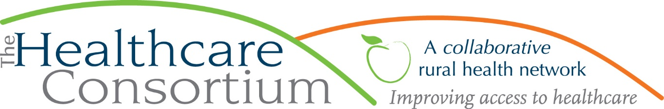

**Minutes of the Governance Committee Meeting of March 30, 2020**

**Attending**:

Board Members: Linda Tripp (Chair), John Thompson; Staff Members: Claire Parde

**Discussion Summary**:

1. **Confirm slate of candidates for board membership**

The Committee confirmed that the following board members will be nominated for re-election to the Board of Directors for a term of two years at the annual meeting on April 1st: Robin Andrews, Consumer; Chelly Hegan, Upper Hudson Planned Parenthood; Casey O’Brien, Columbia-Greene Community College; Theresa Lux, Catholic Charities; Art Proper, Non-Designated; Beth Schuster, Twin County Recovery Services; Ken Stall, Coarc; John Thompson, St. John in the Wilderness Episcopal; and, Nancy Watrous, EDDY Visiting Nurse Association.

**2) Confirm slate of candidates for board office**

The Committee confirmed that the following Directors will be nominated for office for a term of two years at the annual meeting: Robin Andrews as President; Chelly Hegan as Vice President; Jack Mabb as Treasurer; and, Linda Tripp as Secretary.

**3) Confirm recipients of the Friend of the Consortium award**

The Committee confirmed that the recipients of this year’s Anne W. Zittell Friend of the Consortium Award are Beth Schuster and Michael Cole, both of whom are retiring in the current calendar year. Although the Annual Recognition Event had to be postponed, we look forward to celebrating them whenever it is rescheduled. In the meantime, Linda will be sure to recognize them during the Governance Report at the Annual Meeting. Claire will provide Linda with a script for the Governance Report.

**4) Report on representation from CMH, HRHCare and Columbia Opportunities**

Claire reported that CMH, HRHCare, and Columbia Opportunities have all suggested candidates for board membership. The group agreed that we would initiate contact with these potential members later this year to educate them about the organization, network, and board service, and to vet them as potential candidates for board membership. Should they prove suitable, we would aim to onboard them in 2021.

**5) Discuss plans for Annual Meeting**

The annual meeting will occur entirely by video conference call, utilizing the Zoom platform. The agenda has been streamlined to account for this, with non-essential items deferred to a later time. The key action items include approving the annual audit and tax filings, adopting the Title VI transportation program policy, and elections of members. We intend to use the chat function for voting.

**Next meeting: Wednesday, July 22, 2020, at 1:00 p.m.**

*Notes prepared and respectfully submitted by Claire Parde, March 31, 2020*