**Columbia County Community Healthcare Consortium, Inc.**

**Executive Committee**

**Notes from the meeting of January 25, 2017**

**Attending Members:** Robin Andrews, Art Proper, Linda Tripp, Beth Schuster, Tam Mustapha

**Absent Members:** Leitha Pierro, Theresa Lux

**Staff Members:** Claire Parde, John Ray, Lisa Thomas

**CALL TO ORDER**

Meeting was called to order at 9:08 a.m. by President Beth Schuster

Fiscal Highlights

John Ray presented the Fiscal Highlights report (see attached).

Grants receivable - John reported that there are only outstanding vouchers from November and December.

Children’s Mental Health Services Project at Taconic Hills– There was a large unspent balance going into 2016. To utilize some of the funds, we sub-contracted with the Mentor Foundation to provide prevention programming to summer school students, leadership and social media training for “youth ambassadors,” and a trip to the Swedish Embassy in Washington, DC for two select students. Among other outcomes of this project, which ended effective 12/31/16, were the addition of an on-site intake process two days per week and weekly meeting of clinicians, faculty and staff for case review.

Galvan Foundation – These funds were fully expensed in December when we sponsored a second Community Health Worker training. This was considered very successful.

Executive Director’s Report

At this time, Claire provided her Executive Director’s Report (see attached).

Claire will be changing the agency letterhead to reflect the vacancy created when Nancy Benz separated from Camphill Ghent in late December.

A correction was made to the financial support provided by the Dyson Foundation for the Prescription Access and Referral Program. It should be $40,000 instead of $44,000.

We are still waiting for the next round of funding for the NYConnects Expansion and Enhancement Program. We did receive a letter from NYSOFA in December indicating that the funding is forthcoming. Depending on the amount, we may hire another staff person.

Executive Session

Claire, Lisa and John were excused from the meeting at 9:43 a.m. so members could discuss the Executive Director’s contracts for 2016 and 2017, which were found to be unclear about their provision for contributions to her retirement account.

Claire and Lisa rejoined the meeting at 9:52 a.m.

**Robin Andrews made a motion to clarify that the $2,000 contribution to a retirement account that is provided for in Claire’s employment contracts for 2016 and 2017 are in addition to any agency-wide contribution that is made. Linda Tripp seconded the motion. All approved and the motion carried.**

It was noted that if Claire separates from the agency prior to 12/31 in any year, she will not receive the contribution, which is true for all staff. Staff must work 1,000 hours in a year to receive the agency contribution. We have a 3rd party administrator to oversee the plan.

Other discussion

Lisa attended a conference arranged by Healthcare for All New York. She provided an overview of the impact of repealing the Affordable Care Act, which may include loss of the Medicaid expansion, tax credits, Essential Plan and the mandate.

**ADJOURNMENT**

After discussion of the Affordable Care Act, the meeting was adjourned.

The next Executive Committee meeting is scheduled for **February 22, 2017.**

*Notes respectfully prepared and submitted by Lisa Thomas on January 26, 2017.*

|  |  |
| --- | --- |
|  | |
|  |
|  |

|  |
| --- |
|  |

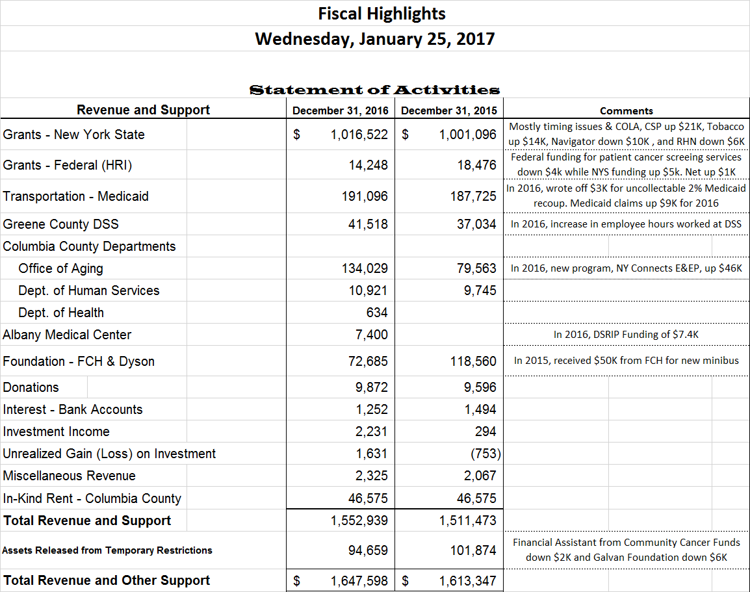

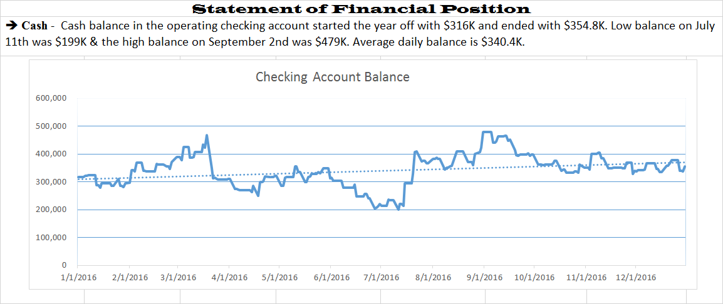

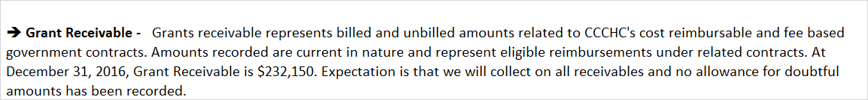

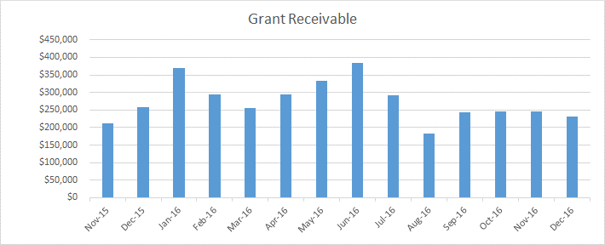

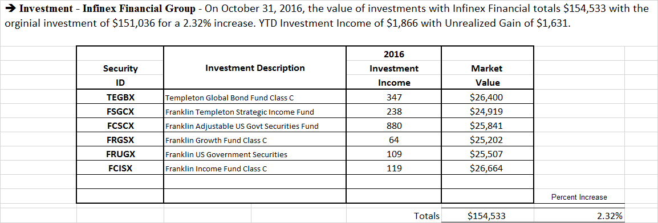

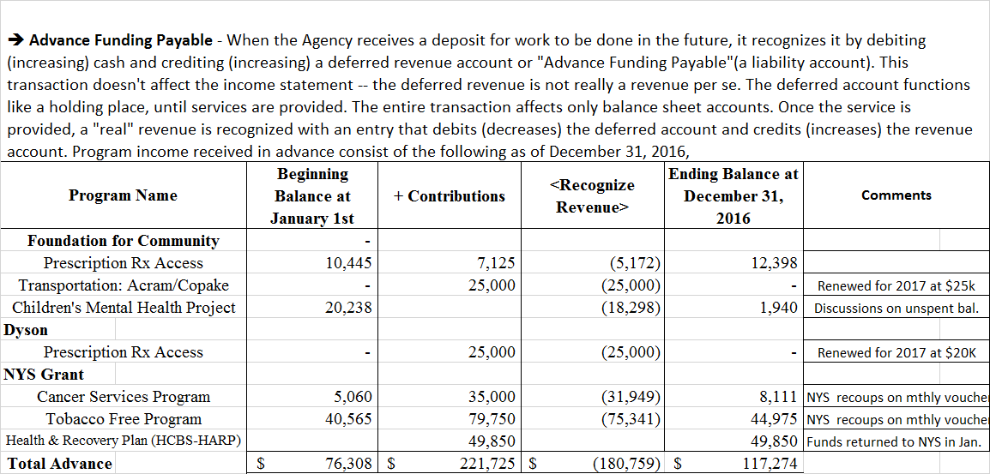

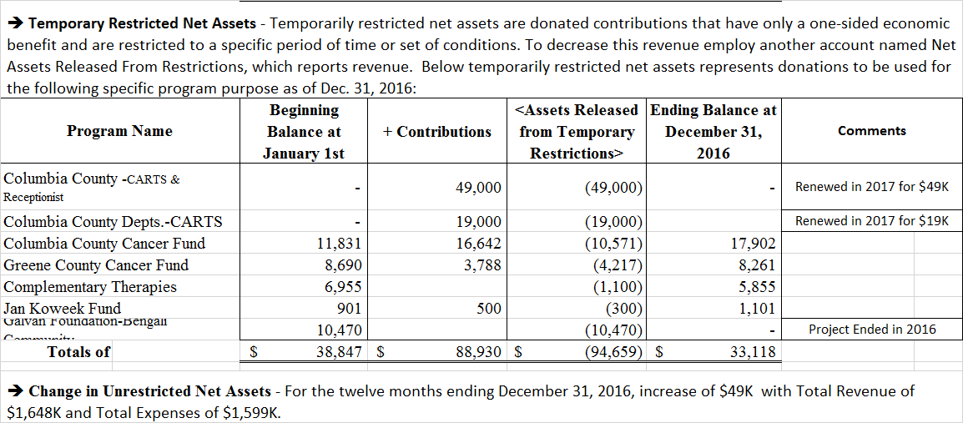

**Columbia County Community Healthcare Consortium, Inc.**

**Executive Committee Meeting**

**January 25, 2017**

**Executive Director’s Report**

**Board and Community Relations**

* I volunteered as an employer for Workforce’s Speed Networking Session on December 8th
* I attended the Greene County Chamber of Commerce’s Holiday Party on the evening of December 8th
* I facilitated the board retreat of the Catskill Community Center on January 8th, 2017
* We were advised that Nancy Benz has separated from Camphill Ghent. Since Camphill Ghent is considered a network member, the implications for us are (1) that Nancy is no longer a board member and (2) that the board position allotted to Camphill is vacant. Robin is in discussion with Deborah Grace about identifying a new representative.
* On Monday night, I was elected to the Board of Trustees of Columbia Memorial Health, a decision that must also be ratified by Albany Medical Center, presumably in February. Therefore, if all goes well, I would expect to attend my first meeting in March.
* The Healthcare Consortium was the first community-based organization profiled in the Center for Health Systems Transformation—the AMCH’s DSRP PPS--newsletter.

**Strategy & Program Planning**

* We submitted a proposal to OASAS in response to the Community Coalitions RFA on December 13th. Our proposal was accompanied by Letters of Support from numerous partner organizations and groups, including the DCS’s in both Columbia and Greene Counties, TCRS, Catholic Charities, CPR and PAS It On, as well as elected officials Senator Marchione, Assemblymember Peter Lopez and Supervisor William Hughes. We have been advised that OASAS will make and announce their selection of grantees in February.
* In the meantime, we continue to participate in a group process to craft a set of recommendations to the CC Board of Supervisors regarding strategic investment of dollars to address the opioid epidemic
* We continue to meet with key network members to plan the Pain Fair at CGCC in 2017
* We continue to participate in the Southern Hub Behavioral Health Planning Group

**Resource Development**

* Our application for ongoing financial support ($44,000) for the Prescription Access and Referral Program to the Dyson Foundation, which we prepared and submitted in November, was funded.
* Our application for ongoing financial support ($25,000) for the Transportation Program to the Foundation for Community Health, which we prepared and submitted in November, was funded.
* We prepared and submitted an application for ongoing financial support ($2,000) for the Greene County Community Cancer Fund to the Bank of Greene County Charitable Foundation. We await their determination (likely, $1,000).
* I invited the Greene County Sheriff’s Office to mimic the recent, very successful fundraiser conducted by the Columbia County Sheriff’s Office in support of No Shave November, during which ~$5,000 was raised for our Columbia County Cancer Fund. The Greene County’s Sheriff Office will be sponsoring “Forget to Shave February,” with all proceeds dedicated to the Greene County Cancer Fund. This is a nice, new partnership with direct benefit to Greene County residents.
* We continue to await the RFP for the next round of funding for the NYConnects Expansion and Enhancement Program. In December, we were issued a notice from NYSOFA that funding is secure and forthcoming, so we have continued this program, despite an effective date of January 1, 2017.

**Fiscal Management**

* Marvin and Company began its pre-audit field work in early December and will be with us again in February.
* The Budget and Finance Committee resolved to recommend the discretionary employer contribution to the agency’s 401(k) profit-sharing plan using a methodology that provides for contributions tied to Years of Service, as follows:

2% of gross wages for all staff with tenure of 0-4 years

+ 1% for all staff with tenure of 5-9 years

+ 1% for all staff with tenure of 10-14 years

+ 1% for all staff with tenure of 15+ years

Furthermore, they will recommend employing this model in all subsequent years, funds permitting, as having a formula greatly facilitates their planning for contributions in grant and contract budgets.

As Claire’s annual employment contracts for both 2016 and 2017 were executed prior to this determination being made, they are unclear in their provisions for contributions to the retirement plan.

**Personnel Management**

* Susan Ortabas, our Office Receptionist and Program Assistant, will take another temporary leave of absence on February 7, 2017 for a second knee replacement. We will once again engage a temporary office assistant from Manpower during her absence.
* Aleshia Boyle separated from the agency on January 14, 2017. We have received numerous applications for her position—now titled Office Manager—and Karen dePeyster, Lisa Thomas, and I will interview 7 candidates today and Friday.
* After an extended leave of absence, Lorraine Deyo, our Fiscal Clerk, formally separated from the agency on December 31, 2017. We have several candidates for her open position to consider.

**Upcoming events**

* I will be participating in the National Policy Institute in Washington, D.C. February 6-9, 2017.