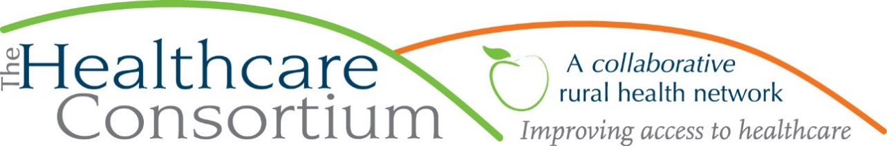

**Executive Director’s Report to the Board**

**October 7, 2020**

**Current Program Updates**

**CARTS**

CARTS continues to operate well below the level at the outset of the pandemic. The following charts depict the number of rides and riders, respectively, by type, for a period starting in early March (our baseline week, before the effects of the pandemic were widely felt) to the present.

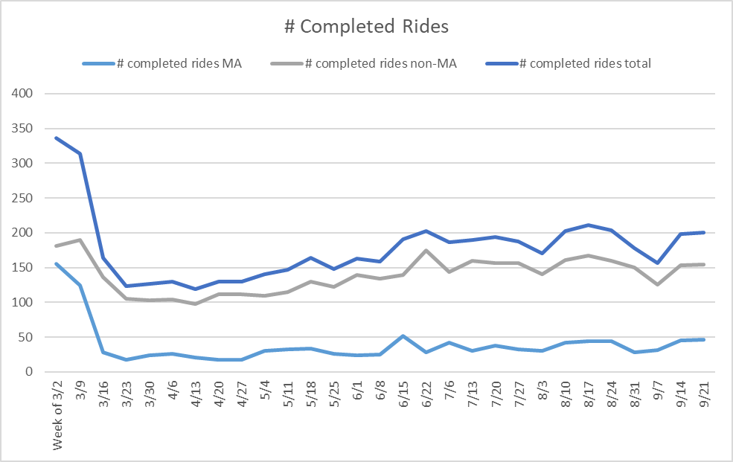

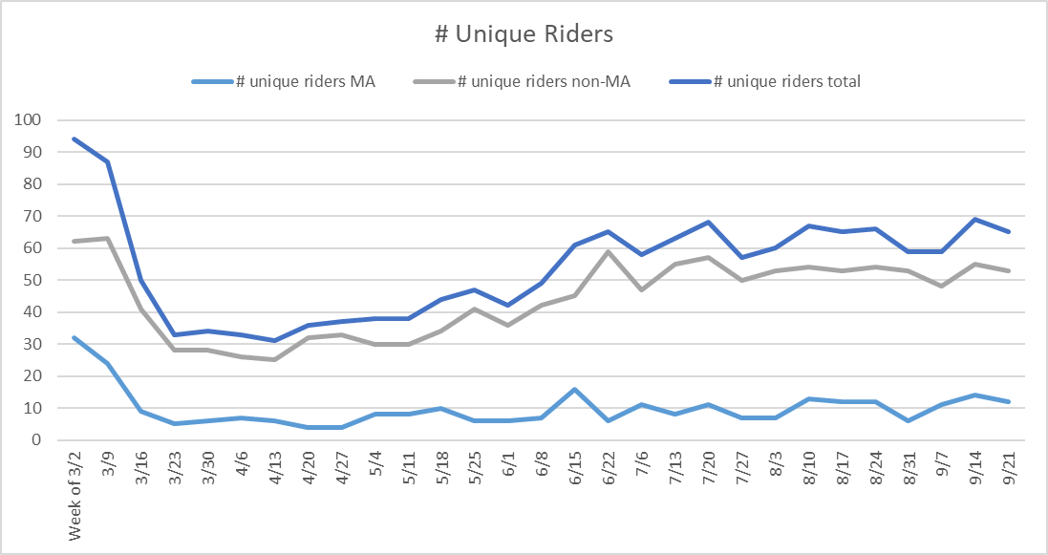

As you can see, while service delivery to non-Medicaid enrollees is about 85% of what it once was, we are currently providing 70% fewer Medicaid rides to 63% fewer Medicaid enrollees. This is most directly tied to the suspension of in-person service delivery to PROS clientele, who constituted the largest part of our Medicaid service delivery.

**State Contracts**

**RHN—**On August 28th, NYSDOH advised us that our RHN award for the period of January 1, 2020 through December 31, 2020 would be reduced from $190,000 to $153,251 (just shy of 20%) as a result of a reduction to the appropriation for the program in the enacted 2020-2021 state budget. We promptly submitted a revised work plan and budget for this amount, but since the amount of the reduction exceeds 10% of the total budget amount, the contract must be amended, rather than simply modified, which involves review by the Offices of the Attorney General and State Comptroller. Until the contract is fully executed, they are withholding payment on our second quarter (April-June) voucher, in the amount of $32,215.

It should be said that the new budget amount is actually greater than we feared (we were planning on being reduced to $130,000). We were also advised that next contract year’s budget amount will be $141,001.

**Tobacco-Free Action--**The last Tobacco Program voucher to be reimbursed in its entirety was for the month of March; although one minor expense from the April voucher was reimbursed because it represented an expense from the prior fiscal year (travel in March), the State seems to be withholding payment for any expenses incurred in the current fiscal year (April 1 onward).

Although the start date for the next contract period is July 1, 2020, we continue to operate under the prior contract year’s budget, as we have not been invited to submit a budget or work plan as yet. We have, however, been asked to plan for a reduction of some amount, estimated at 20%. While waiting for additional guidance, Tobacco Program staff continue to work reduced hours (.7 FTE) and all hiring and discretionary spending is on hold.

**Navigator--**Interestingly, the Navigator Program has remained fairly current, reimbursing vouchers, in their entirety, through July. We were also invited to submit a budget for the entire award amount, though that certainly does not preclude a cut later.

**County Contracts:**

**NY Connects, MIPPA, & HEAling Communities Study** vouchers thru June’20 have all been paid

**ADRC**-We have recently executed another contract with the Columbia County Office for the Aging to manage a small amount of money (~$14K) on their behalf. These funds, which are dedicated to COVID-relief for eligible participants, will be managed much like requests to our Prescription Access and Referral Program or Financial Assistance Funds.

**Other Contracts:**

**ICAN**-We have successfully renegotiated our subcontract with the Healthy Capital District Initiative (HCDI) for the Independent Consumer Advocacy Network for the period of May 1, 2020 through April 30, 2021 in the amount of $17,510.

**Private donors:**

* We have been fortunate to receive $2,500 from Brinder Habeck of Kinderhook Toyota, a generous and reliable donor to the Consortium, which we expect will be matched by the Toyota Foundation
* We unexpectedly received $5,000 from an anonymous donor through the Triskeles Foundation.
* We felt privileged to be contacted by our friends at the Rip Van Winkle Foundation, who provided $30,000 to the Healthcare Consortium to offset General Operating expenses.

**Personnel Updates**

**New personnel policies**

**Remote Work**—As previously reported, we’ve been operating under procedures communicated to staff via memo and in the workplace safety plan, but felt that a more durable personnel policy was needed. We developed a draft that was then reviewed and refined by the attorney at NYCON, and for which approval is now sought.

**NY Paid Sick Leave**—This new legislation currently provides paid sick leave for temporary casual/per diem workers, which our current PTO policy did not do; should this version of the legislation persist, we expect it to add to our labor costs, particularly in Transportation. However, the State has not provided sufficient guidance for us to develop and/or modify policies to respond, and all the counsel we have received has advised us to delay doing so at this time.

**Payroll Tax Deferral**—We opted to not provide employees with the opportunity to defer the Social Security portion of their income tax from September 1st through December 31st, for two reasons: (1) we were concerned that employees would have difficulty repaying the deferred tax in the first quarter of 2021, and (2) we did not want to assume the liability for their deferred taxes, should they separate.

**Update on the Strategic Plan**

While the pandemic has certainly interrupted many of our plans, I remain mindful of the goals that we outlined in our strategic plan, and still aim to advance them when and where I can. As you may recall, one of our goals was to provide staff with competitive compensation. As a starting point, we were able to commission a company to conduct an agency-wide compensation study, which was completed in the early part of this year. This helped to highlight a number of positions that are undercompensated by a substantial percent (10% or more). Although this is not the year to make substantial upward adjustments to any person’s base rate of pay, the Paycheck Protection Program provided us with an opportunity to advance this goal by providing “one time retention incentives” that bring each recipient closer to their 2020 compensation goal.

**Board and Community Relations**

* You may recall that I had participated in a multi-stakeholder workgroup focused on Primary Care Quality Ratings. A similar group has been convened to consider what and how to share pricing information from the All Payer Database (APD). I have participated in two workgroup meetings thus far, with several more planned for the balance of 2020 and into 2021.
* I continue to remain very active on the boards of Columbia Memorial Health, Twin County Recovery Services, the New York State Association for Rural Health, and the Catskill-Hudson Area Health Education Center, as well as the Columbia County Community Services Board and its Alcohol and Substance Abuse Committee, which I currently chair.