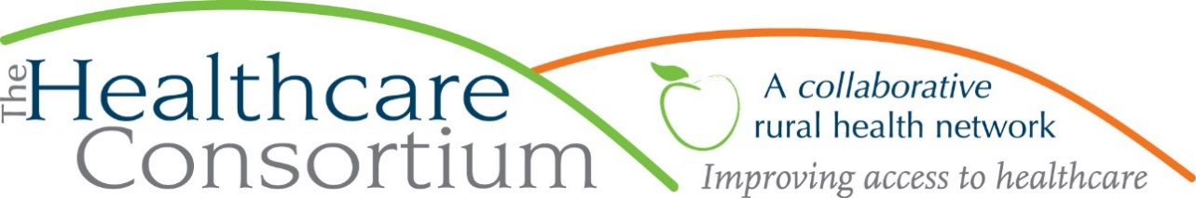

**Executive Director’s Report to the Board**

**December 2, 2020**

**Current Program Updates**

**CARTS**

CARTS continues to operate well below the level at the outset of the pandemic. The following charts depict the number of rides and riders, respectively, by type, for a period starting in early March (our baseline week, before the effects of the pandemic were widely felt) to the present.

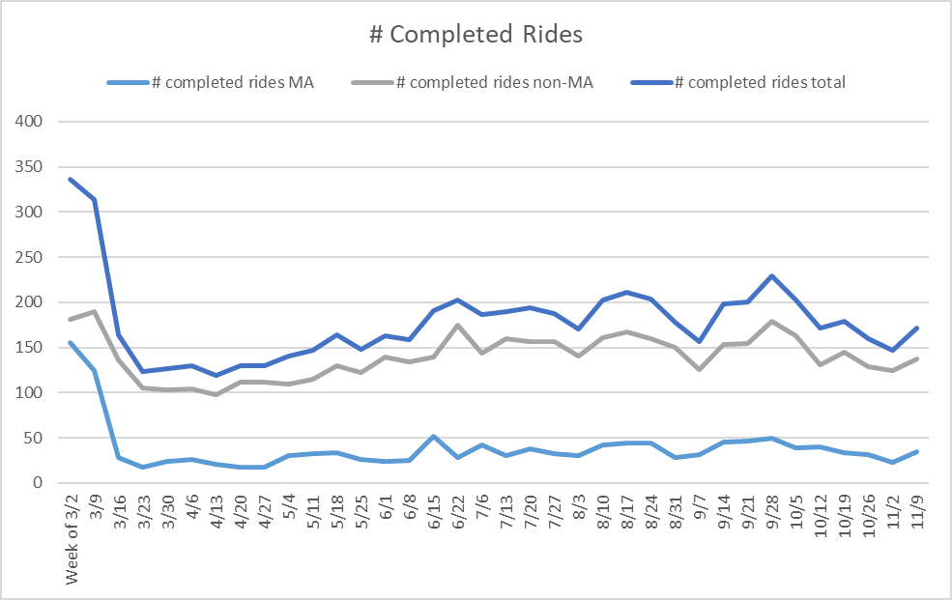

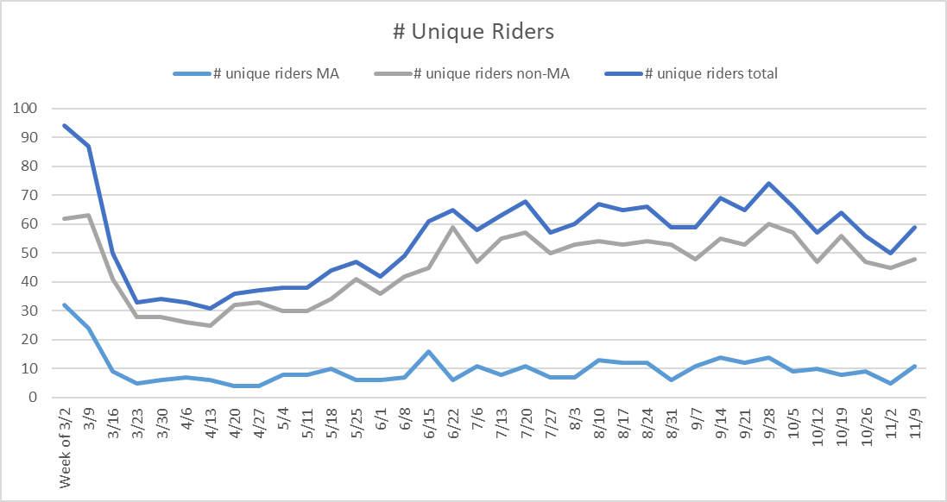

While service delivery to non-Medicaid enrollees is about 75% of what it was during the same period last year, service delivery to Medicaid enrollees remains at less than 25%. This is most directly tied to the suspension of in-person service delivery to PROS clientele, who constituted the largest part of our Medicaid service delivery. At this time, rides to non-payers (that is, people for whom there is no reimbursement mechanism in place) constitute about 80% of all rides, and non-payers are about 84% of our ridership. This is good from the perspective of meeting the need of people with few options, but not so good from the perspective of revenue to the program. At this time, we’ve earned a little more than $78,000 LESS in Medicaid revenue than at the same time last year.

Not all the decreases in Medicaid revenue are a result of lost business. They also reflect decreases in the Medicaid reimbursement rates themselves. Effective June 1, 2020, base (A0100) and mileage (S0215) reimbursement rates were reduced by 7.5% and on December 1, 2020, they were further reduced by 8.1%, for a total reduction of 15%:

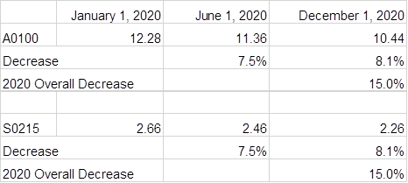

***Takeaway: CARTS is recovering, albeit slowly, but new sources of revenue to the program must be found to offset losses in Medicaid revenue, including foundation support and, possibly, fees to ridership.***

**State Contracts**

**RHN—**The RHN contact was fully executed and our vouchers are being reimbursed, albeit at 80% of the vouchered amount. At this time, we assume the 20% withholding will eventually be paid, but the timing is unclear.

**Tobacco-Free Action--**The last Tobacco Program voucher to be reimbursed in its entirety was for the month of March. April, May and June vouchers totaling $62K are now pending payment; we anticipate that they will be reimbursed at 80% as well. We also expect that this will be the LAST money we see from the Tobacco contract in 2020, as the new contract for the period starting July 1, 2020 has not been initiated as yet. While waiting for additional guidance, Tobacco Program staff continue to work reduced hours (.7 FTE) and all hiring and discretionary spending is on hold.

**Navigator--**Interestingly, the Navigator Program has remained fairly current, reimbursing vouchers, in their entirety, through July. The new contract for the period starting August 1st, 2020 has also been fully executed, and we are now invited to submit August, September, October and November vouchers, in 2 week increments, for reimbursement. As a result of a recent retirement, we will soon be seeking to hire a new Navigator.

***Takeaway: The State coffers are loosening up for us a little bit, but there remain open questions about whether and when the 20% withholding will be paid, and also when the Tobacco contract will be executed and in what amount.***

**Personnel Updates**

October and November were busy months in terms of managing staff expectations and actions. Following the Board’s approval of the new remote work policy, we initiated a process to “tuck” all staff under this new policy.To our pleasant surprise, the process went very smoothly. We also initiated off-site service delivery, as well as outreach during this time. There was some initial trepidation and even some reluctance among staff about this, but our experience has generally been that once people actually conduct outreach and offsite service delivery, their comfort level with it increases very quickly.

**Update on the Strategic Plan**

While the pandemic has certainly interrupted many of our plans, I remained mindful of the goals that we outlined in our strategic plan, and still aimed to advance them when and where I could. As you may recall, one of our goals was to provide staff with competitive compensation. As a starting point, we were able to commission a company to conduct an agency-wide compensation study, which was completed in the early part of this year. This helped to highlight a number of positions that are undercompensated by a substantial percent (10% or more). We were able to utilize funds from the Paycheck Protection Program to provide select staff with “one-time retention incentives” that brought each recipient closer to their 2020 compensation goal, and more recently, we were able to implement planned and budgeted increases for a number of staff. It is my observation that these “bumps” to wages provided a real boost to morale.

***Takeaway: Despite the challenges of this unique year, we were able to significantly advance our strategic objective of enriching compensation.***

**Odds and Ends**

We were grateful to receive a donation in the amount of $200 from Columbia County 911 services and another in the amount of $5,500 from the Columbia County Sheriff’s Office for our Columbia County Community Cancer Fund.

**Board and Community Relations**

* On October 20, I met with Dr. Steve Frisch, Senior Executive Vice President for the Integrated Delivery System at Albany Medical Health System, to discuss the Consortium in depth.
* On October 29th, I participated in the Why Means Matter: Suicide Prevention Training hosted by the Columbia-Greene Suicide Prevention Task Force
* On November 12th, I participated in the Community Advisory Committee of the NYS Health Foundation
* On November 13th, I participated in Congressman Antonio Delgado’s Healthcare Advisory Committee meeting
* On November 17th, I participated in the Price Methodology Workgroup convened by NYSDOH.
* I continue to remain very active on the boards of Columbia Memorial Health, Twin County Recovery Services, the New York State Association for Rural Health, and the Catskill-Hudson Area Health Education Center, as well as the Columbia County Community Services Board and its Alcohol and Substance Abuse Committee, which I currently chair.