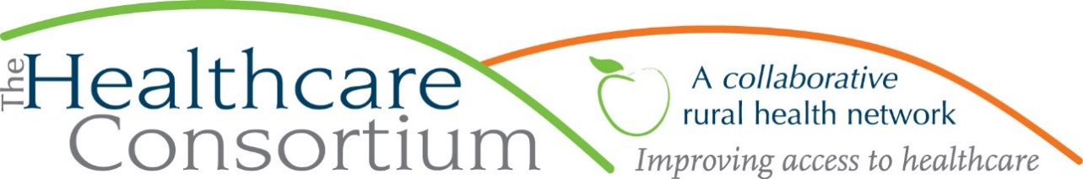

**Executive Director’s Report to the Board**

**February 3, 2021**

**Program Updates**

**CARTS**

CARTS continues to operate well below the level at the outset of the pandemic. The following chart presents the number of **rides**, by type, for a period from 03/16/20 to 01/22/21 compared to the same time frame in 2019:

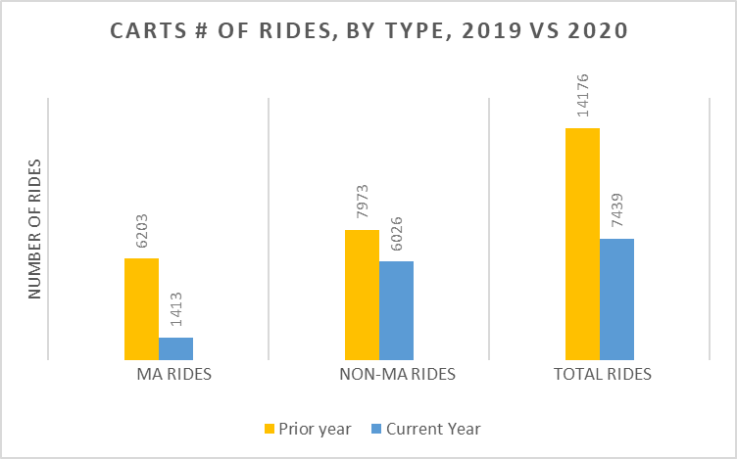

Similarly, the following chart presents the number of **riders**, by type, for a period from 03/16/20 to 1/22/21compared to the same time frame in 2019:

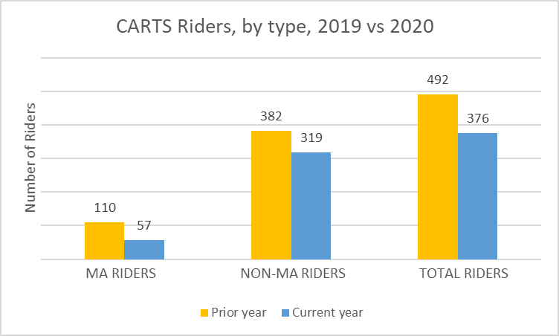

As these charts make clear, both rides and ridership decreased during this timeframe. The following table presents the percent decrease in each category:

|  |  |  |  |  |  |  |  |  |  |  |  |  |
| --- | --- | --- | --- | --- | --- | --- | --- | --- | --- | --- | --- | --- |
|  | **# completed rides** | | | | | | **# unique riders** | | | | | |
|  | **MA** | **% change** | **non-MA** | **% change** | **total** | **% change** | **MA** | **% change** | **non-MA** | **% change** | **total** | **% change** |
| 3/18/19-01/24/20 | 6,203 |  | 7,973 |  | 14,176 |  | 110 |  | 382 |  | 492 |  |
| 03/16/20-01/22/21 | 1,413 | -77% | 6,026 | -24% | 7,439 | -48% | 57 | -48% | 319 | -16% | 376 | -24% |

While we provided just less than half of the trips during this period that we had in the prior year, the majority of the decrease can be attributed to the reduction in Medicaid-reimbursable rides. Similarly while our overall ridership decreased by about 24%, our Medicaid ridership decreased by nearly half. This translated to a substantial reduction in Medicaid revenue, approximately $90,500 less in 2020 than in 2019.

**State Contracts**

**RHN—**We have been reimbursed for the second and third quarter vouchers, albeit at 80% of the vouchered amount. We also received a communication in late December that, although our 2021 contract amount was confirmed to be $141,000, in lieu of withholding 20% of all future claims for payment, the Department of Health will approve new period budgets in which 20% of funds have been withheld and reserved in the “other” category, as a restricted, unbillable line item. The balance of the annual contract value ($112,801) can be budgeted to support the program and future claims will be paid at 100%. Since that communication, we have been waiting for the State to invite us to submit a budget in this new amount.

**Tobacco-Free Action—**On Friday, January 29th, we received a notification that our Tobacco Control contract has been reduced by 14%--a welcome reprieve, as we anticipated a 20% reduction. We will have until Friday, February 19th to submit a work plan and budget in this amount. On Monday, February 1st, Kristy Tillman submitted a letter of resignation, effective February 19th. Kristy has accepted an opportunity with AmeriCorps to work in Iowa, starting in March.

**Navigator—**A second round of advertisements garnered us four complete applications for our vacant Navigator position; all four candidates are scheduled for interviews this week.

**Resource Development**

Board Member Chelly Hegan was good enough to arrange a meeting for me with herself, UHPP’s VP for Development, Anne Leiber, and Development Consultant, Michele Susko. That meeting, which occurred on Friday, January 22nd, was tremendously helpful in demystifying fundraising and particularly the process of developing donors. A loose plan was developed which will entail a joint event later this calendar year, and the sharing of Anne’s expertise in monthly meetings—a serious commitment of support from UHPP. Meanwhile, Michele has submitted a proposal for her services which would entail six months of support, including one meeting per month with additional phone and email support, billed at $1,500 per month. This should give us enough time to develop a plan for the next couple of years and begin to implement some of the strategies. I recommend the Board approve this modest investment.