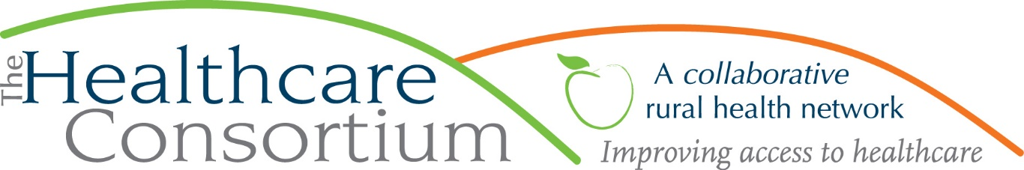

**Executive Director’s Report to the Board**

**February 2, 2022**

**Fiscal Management**

**New York State Contracts**

* TOB—We continue to await approval on the Year 3 budget and work plan for the **Tobacco Control Program** that began on July 1, 2021. In the interim, however, NYSDOH IS reimbursing expenses against the contract, and we are current through November.
* NAV—NYSDOH has reimbursed expenses against the **Navigator Program** contract through October.
* RHN—We submitted the fourth and final voucher and performance report for the last contract year, ending December 31, 2021, of the **Rural Health Network Development Program.** When the contract year is fully closed out in the NYS Grants Gateway, we will be invited to submit a budget and work plan for the 2022 grant year (January 1-December 31, 2022).
* ***Takeaway:*** ***All NYS contracts are basically current, and anticipated to renew without issue.***

**Foundation Contracts**

* I completed a final report for the Dyson Foundation’s two-year, $98,000 General Operating Support Grant that just ended on December 31, 2021. Recall that the Dyson Foundation renewed its support to the Consortium, granting another two-year, $100,000 General Operating Support Grant for the period beginning January 1, 2022 and ending December 31, 2023.
* In addition to all the regular and usual program reports due to FCH, I also met with Natashea Winters to provide an interim report on the 3-year, $100,000/year General Operating Support Grant from FCH.
* ***Takeaway: Our Foundation partners continue to be an important source of support to programs and operations.***

**Other Contracts**

* Kim Kaplan, Director of the Greene County Public Health Department, requested that the Consortium represent that agency in the collaborative community health improvement planning activities, much as we currently do for CMH. Kim and I are in the process of finalizing that contract, which will cover the term of January 1 through December 31, 2022. I, in turn, hope to subcontract with the Greene County Rural Health Network to assist me, which would allow the two agencies to partner in a way they have not as yet, and also provide its relatively new Executive Director, Toni Carroll, an opportunity to be exposed and engaged in this kind of work, which is so fundamental to the charge of Rural Health Networks. In the next week or so, I will be outlining the terms of the subcontract (i.e. timeline, deliverables, reimbursement rate and timing) and expect to meet with the GCRHN’s Executive Committee to further explain the arrangement.

**Advocacy**

As you likely already know, I am a board member of the New York State Association for Rural Health (NYSARH). Last fall, I became chair of its Policy Committee and have been leading NYSARH’s state advocacy efforts. Last week, I personally met with the following elected officials and/or members of their staff:

* Assemblymember Donna Lupardo
* Senator Rachel May
* Senator Samra Brouk
* Assembly Minority Leader Will Barclay
* Assemblymember Linda Rosenthal
* Speaker Carl Heastie
* Assemblymember Aileen Gunther
* Senate Minority Leader Robert Ortt
* Assemblymember Richard Gottfried
* Senator Michelle Hinchey

Others in our delegation also met or will meet with the following offices:

* Assemblymember Angelo Santabarbara
* Senator Billy Jones
* Senator Gustavo Rivera
* Senator Roxanne Persaud
* Senator Majority Leader Andrea Stewart Cousins

Our advocacy positions fall into 9 major themes:

1. Invest in Rural Health Programs by restoring full funding ($16.2M) to the Rural Health Network Development & Rural Access Hospital Programs
2. Empanel the Rural Health Council
3. Enhance State support for Rural EMS
4. Repeal the 340B Pharmacy benefit Medicaid Managed Care carve-out
5. Ensure Adequate Public Health Infrastructure
6. Support Mental & Behavioral Health
7. Support Aging & Disability Services
8. Expand Rural Broadband & Telehealth
9. Promote Workforce Recruitment, Training & Retention

**Community Relations**

* On February 7th, I will facilitate a special “vision and mission” review for the CMH Board
* On February 9th, I will participate as panelist in HRSA’s Region 2 Rural Health Roundtable
* Later the same day, I will be interviewed by Susan Arbetter from Capital Tonight
* On February 11th, I will attend Assemblymember Didi Barrett’s Human Services Advisory Council meeting
* On March 10th, I will facilitate a meeting of community partners to conclude the community health needs

assessment process

* On March 19th, I will facilitate a day-long strategic planning retreat for the Coarc Board of Directors

**Board Relations**

3/2 Executive Committee 9:00 am

3/2 Corporate Compliance Committee 10:00 am

3/22 Budget and Finance Committee 3:00 pm

3/23 Governance Committee 1:00 pm

4/6 BOARD OF DIRECTORS ANNUAL MEETING 2:30 pm