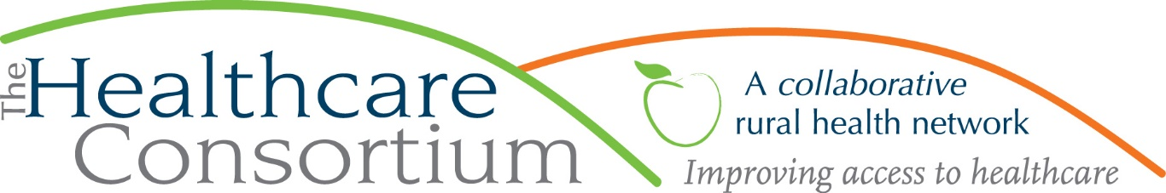

**Executive Director’s Report to the Board**

**August 3, 2022**

**Fiscal Management**

**New York State Contracts**

* TOB—The contract for our **Tobacco Control Program** is paid through May. The June voucher, which is the final for the contract year (July 1 thru June 30), has been submitted. The budget and work plan for Year 4, starting July 1, 2022, have also been submitted and we are now awaiting approval, which we anticipate will take several weeks. In the meantime, NYSDOH permits us to voucher for expenses using the prior contract year’s budget.
* NAV—NYSDOH has reimbursed expenses incurred by the **Navigator Program** contract through April. The budget and work plan for Year 4, starting August 1, 2022, have been submitted and we are now awaiting approval, which we anticipate will take several weeks. In the meantime, NYSDOH does NOT permit us to voucher for expenses until the new budget year
* RHNDP—We have been reimbursed for all first quarter expenses associated with the **Rural Health Network Development Program.**
* ***Takeaway:***  ***All NYSDOH contract budgets are reimbursing expenses timely.***

**Other Contracts**

* NYC--We submitted the subcontract budget for the current **New York Connects** contract period, which began on April 1, to CCOFA, which in turns submitted it to NYSOFA. We are now awaiting approval, which historically takes NYSOFA a few months. In the meantime, CCOFA contracted with the Consortium at the county level, permitting us to voucher and be reimbursed for expenses.
* RHN TA—We have fully expended the **Rural Health Network Technical Assistance** funds in the amount of $9,750 to offset the expense associated with our contract with M.S. Hall & Associates. That was a nice bit of supplemental funding that permitted us to basically pay for the strategic design project using external funds.
* GCDHS—Our contract with Greene County to provide transportation services to the clients of the **Greene County Department of Human Services** has been approved by the Greene County Legislature. Team from both agencies will be meeting soon to discuss how to operationalize the partnership.
* FCH—July 30th was the deadline for a fair bit of reporting to the **Foundation for Community Health** for funding related to the Prescription Access and Referral Program, the Transportation Program, and the General Operation Support.

**New Funding**

* The Bank of Greene County Charitable Foundation awarded the Consortium $2,500 to support its Community Cancer Funds
* Kinderhook Toyota provided a donation in the amount of $2,500 to support the Columbia County Community Cancer Fund; the Toyota Foundation will match this award.

**Personnel Management**

* We have been advertising for two part-time Public Health Americorps Members—one as a Health Educator and another as a Transportation Program Assistant--and had the opportunity to interview a candidate for the first role last week.
* We anticipate that one of our Navigators will need to take a 12-week family leave shortly.

**Program Management**

* Transportation--The first of the vehicles for our **Children and Adults Rural Transportation Service (CARTS)** ordered last fall through Enterprise Fleet Management has arrived. The remaining four vehicles ordered at the same time have not been built as yet. Also, we have contracted with Kinetik, which is a Medicaid billing software program that we’re trying to save staff time on billing.
* Consumer Assistance Programs--Since the **Prescription Access and Referral Program** and the **Financial Assistance Funds** are now being managed by staff member Rachel Cole, we have spent a considerable amount of time reviewing and improving our processes around documentation, reporting, etc.

**Board and Community Relations**

* On June 14th, I met with Kathleen Eldridge, our CC Board of Supervisors Representative to the Consortium’s Board, to provide an orientation to the agency
* On June 30th, the new board members and their mentors met with Board President Scott Thomas and myself for a new board member orientation meeting

**Upcoming Board and Committee Meeting Dates**

9/7 Executive Committee 9:00 am

9/7 Corporate Compliance Committee 10:00 am

9/27 Budget and Finance Committee 3:00 pm

10/5 Board of Directors 2:30 pm

**PLEASE NOTE:** Board meetings will take place in the Saland Forum, Room 614, at Columbia Greene Community College. This room provides adequate space for social distancing, as desired, and is well-equipped to support remote participation for anyone who needs/wants to “Zoom in.” For the sake of convenience, committee meetings will continue to be conducted via Zoom.