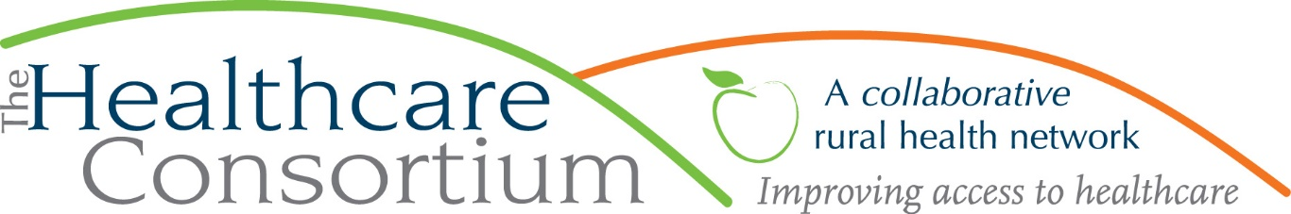

**Executive Director’s Report to the Board**

**April 5, 2023**

**Fiscal Management**

* New York State Contracts
* Reimbursement for expenses incurred by the **Navigator Program** is current through January
  + Reimbursement for expenses incurred by the **Tobacco Program** in January is currently pending
  + The **RHN Program** contract year begins on January 1st. In early March, we were asked to submit our program budget and work plan, which was promptly approved. We will submit the first quarter voucher for the period between January 1 and March 31
* County Contracts
  + Lisa Thomas has done another excellent job spending down the budget for the **NYConnects Program**, which ended March 31, 2023; keep your ears peeled for radio ads on iHeart Media and for print ads in the Columbia Insider
  + Our contracts with the Columbia County Department of Health for the **HEALing Communities Study** ended on March 31, 2023. Keep in mind that the absence of these contracts will be felt as both a reduction in revenue on the balance sheet and a reduction in earned income from the administrative fees we charged
* Foundation support
* We have been invited to submit a request for General Operating Support to the Dyson Foundation for 2024 and 2025
* Reminder that in July, we will receive the third and final allocation of General Operating Support, in the amount of $100,000, from the Foundation for Community Health

**Program Management**

* Considerable attention is being devoted to the **Children and Adults Rural Transportation Service**, and operational changes are being made to reduce our expense profile. This has included scrutinizing our lease arrangements to make sure our vehicle fleet is “right-sized,” changing scheduling practices to reduce the number of out-of-town trips, and optimizing Medicaid-reimbursable service delivery. The Transportation Team is meeting frequently, and constantly evaluating trips and driver hours to ensure that we stay within the approved program budget.
* Through a contract with CMH, I continue working on **Community Health Improvement/Service** **Plan Implementation** in partnership with both departments of health. The Planning Partners host monthly Plan Implementation Meetings and quarterly workgroup meetings with other community partners.

**Personnel Management**

* We continue to advertise for three vacant positions:
* A full-time Navigator with our Navigator Program (health insurance enrollment services)
* A full-time Community Engagement Coordinator with our Tobacco-Free Action Program
* A Director of Development and Communications

Regarding the last: We originally advertised this as a full-time position for annualized wages up to $50,000. Having received essentially no response, we more recently began to advertise this as a 25 hour/week position for the same annualized wages. While we have received a few applications, they appear to be responding to the Communications side, rather than the Development side, of the position. We expect that ultimately we will need to hire a development consultant to work in tandem with a more junior member of the staff (i.e. an internal workhorse). Toward that end, we will develop a Request for Proposals (RFP) for that consultant’s role. We would be grateful for the input of any Board members who have experience with engaging development consultants and/or have a list of consultants to whom we could circulate the RFP.

Please see all of these employment opportunities(and share them!) at <https://www.columbiahealthnet.org/about/employment/>

* Update on RHN Coordinator Position: As previously reported, Victoria Juliano, who is currently a Navigator, accepted the offer to move into the role of RHN Coordinator. However, since we have been unable to fill the Navigator role vacated earlier in the year by Rachel Cole, we have delayed moving her into that position for fear of under-resourcing Navigator. Victoria is naturally frustrated by the delay, but patient. In the interim, I have engaged in our efforts to plan the Annual Recognition Event and Fundraiser, a task with which she’s doing quite well.

**Board and Community Relations**

* Governance Chair Robin Andrews and I met separately with each of the new board member candidates
* I have become involved with the Columbia County Opioid Settlement Workgroup and have been asked to moderate four community listening sessions at various locations throughout Columbia County
* On February 8th, I met with David Harrison, Columbia County Emergency Services, to talk about Consortium’s programs and capacity to assist during emergency events
* On February 16th, I met with the Health Promotions Team from Glens Falls Hospital to learn more about their work
* On February 17th, I attended the State Budget Briefing organized and presented by HANYS
* On March 6th, I presented to the Leadership Team for the CMH Ladies Auxiliary
* On March 7th, we hosted dental students from NYU
* On March 8th, I attended the Women’s Networking Lunch hosted by the Columbia County Chamber of Commerce
* On March 9th, I attending a Transforming Healthcare “Power Breakfast” hosted by the Albany Business Review
* On March 15th and 28th, I attended the Public Hearings on the County’s Transportation Coordination Plan
* On March 20th, I met with Brendan Cudmore from Main Street Rural Health

**Upcoming Board and Committee Meeting Dates**

5/3 Executive Committee 9:00 am

5/3 Corporate Compliance Committee 10:00 am

5/23 Budget and Finance Committee 3:00 pm

6/7 Board of Directors 2:30 pm