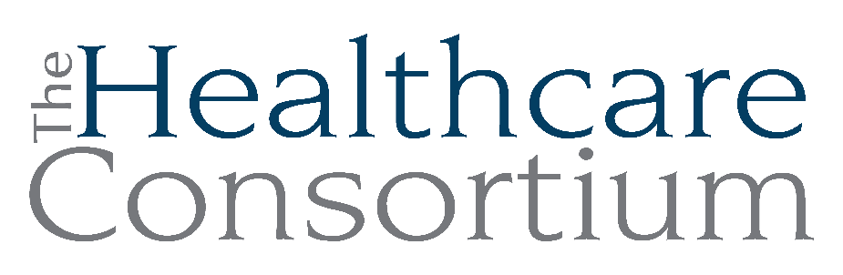
Notes from the Executive Committee meeting of May 1, 2024

Note: This meeting was held virtually on the Zoom web platform

Attendance
Committee Members: Becky Polmateer, Scott Thomas, Art Proper, Robin Andrews, Jack Mabb
Absent Committee Members: None
Staff Members: Claire Parde, Lisa Thomas

Report on the Annual Recognition Event

The Annual Recognition Event was held on April 11th at the Wick. The event itself was quite nice and people were happy to be together. It was a great tribute to Karen dePeyster. However, the space and service weren’t adequate. The AV equipment was not working well, the servers did not make an effort to offer food to guests, the food was plain with limited gluten-free options, alcoholic drinks were expensive, and the acoustics in the room made it difficult to hold conversations. We will not be using this space for future events.

The Committee felt it was the right decision to hold the Annual meeting immediately following the regular Board meeting before guests arrived. The Committee also discussed having auditorium-style seating during the program next year.

Utilizing our new donor database, Bloomerang, eased the administrative burden of hosting the event since people could register and make payments directly online. The site was set up to automatically send a donation acknowledgement, which can also serve as a payment receipt for tax purposes.

A digital thank you message was also sent to all attendees and sponsors. The card included a link to the Consortium’s Impact Report and listed the sponsors.

The financial results of the event are as follows:
- Revenue: $5,145.56
- Expenses: $2,255.42
- Net: $2,890.14 (These funds will go to the Consortium’s Community Cancer Funds.)

Other Updates on Development and Communications

The Consortium’s first ever quarterly newsletter was sent out. Subsequent issues will follow the same format. The Network Member Spotlight focuses on and supports Network Members in their own efforts to promote events. We will also use our social media and distribution lists to promote members and what they are trying to accomplish. With these efforts, we are exploring the idea of Network Member dues.

The CARTS fundraiser will be held on Thursday, August 1st at Upper Depot Brewery. It will be a casual event. It was decided to hold it in the summer so as not to compete with other fundraisers. This event is separate from our end-of-year campaign.

Claire and Robin have started the process for onboarding Nina Benvenuto, the new Administrator of Columbia County Office for the Aging, to the Consortium’s Board of Directors. The plan is to elect her at the June Board of Director’s meeting.

A new Board member orientation meeting will be later in June for the four new Board members and their mentors. This meeting will be further discussed at the May 15th Governance meeting.

Strategic Planning: Process and Timing

The current Strategic Plan is for five years from 2020 to 2024. Even though COVID disrupted the Plan, there were accomplishments. The Committee discussed revisiting the Plan and cataloging work that was completed, partially completed, and not completed. It makes sense to bring a small group together first to review the Plan and the SWOT analysis, which will inform next steps. Jack, Scott, Becky and Robin all indicated that they are willing to be part of this initial group. Other Board members will be invited to join the group at the June Board meeting. The entire Board will be involved at a later date. Claire would like to include Nathan McLaughlin, Director of Consumer Assistance Programs, in this process as he brings a lot of experience. Claire will schedule an in-person meeting by the end of May.

The Strategic Plan has been a helpful guide to inform decisions. It was mentioned that it should be shared with new Board members at orientation.

The Consortium will be surrendering the Tobacco-Free Action grant on June 30th. We will need to think about our focus going forward. Will we strictly focus on direct service delivery? We will also need to look at those programs which are income-transfer programs. They include the Prescription Access and Referral Program and the Financial Assistance Funds. These programs draw from general operating support, which limits funding to CARTS.

Other Updates

Claire is very pleased with new staff. Nathan McLaughlin, Director of Consumer Assistance Programs, is a great addition. Emi Davenport, Navigator, is fully trained. Lisa Thomas, Director of Business Operations, and John Ray, Director of Finance, have new job descriptions. John is looking to retire, and we will be advertising for the position soon.

We are planning to transition the Tobacco-Free Action Program to Ulster County. We have provided Ulster County with a guidance document for transferring digital assets.

A letter of intent to apply for $125,000 to the Mother Cabrini Health Foundation was submitted for CARTS. It does appear that we will be awarded this money. Claire also considering approaching the Hudson River Bank and Trust Foundation (HRBT) and possibly the Rheinstrom Hill Community Foundation as well.

Next meeting
The next meeting of the Executive Committee will be on July 3, 2024 at 9:00 a.m. via Zoom.

