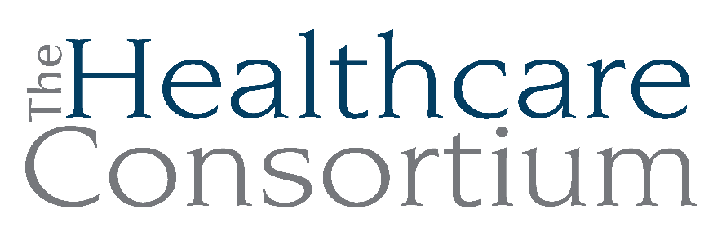

Executive Director’s Report to the Board
June 5, 2024

Fiscal Management
- NYS Grants and Contracts:
- Tobacco (TOB): We have submitted a claim for payment through April and have been reimbursed for expenses incurred on this contract through March. We also must submit a budget modification for the current Year 5 budget to capture salary and fringe expenses incurred since July 2023, but have been unable to do so due to significant delays on the part of the Bureau of Tobacco Control (NYSDOH).
- Navigator (NAV): We submitted vouchers through April and have been reimbursed through February.
- Rural Health Network (RHN): We submitted a claim for payment for the 1st quarter (January 1 – March 31, 2024) and have been reimbursed. We have been informally advised that the current contract, already in its 6th year, will be further extended by at least 6 months, ending on or near June 30, 2025. The Request for Applications (RFA) for the next 5-year contract is expected by July 1, 2024.
- Columbia County grants and contracts: Our vouchers for expenses related to senior transportation and NYConnects have been reimbursed by the County through March; additionally, we received the second half ($26K) of our County Budget appropriation ($52K total)
- External Audit of Financial Statements: Unfortunately, the auditors at Bonadio have not completed their work on the audit of the Consortium’s Financial Statements, or their preparation of the federal tax filing, IRS Form 990. We anticipate that the work will be completed shortly, and propose that an ad hoc audit committee of independent directors is formed to meet with the auditors and approve the tax filing.

Personnel Management
- Recent separations, hires, and vacancies
- Our advertisements for the vacant position of Program Assistant with the Navigator Program, which would perform a number of duties associated with the program including responding to inquiries, scheduling appointments, and greeting and directing consumers, has not yielded any applicants as yet.
- John, Lisa and I interviewed a very promising candidate for the position of Director of Finance, and are currently exploring our options for accommodating a request to work out of state periodically.
- Our Navigator, Elaine Allen, continues to be out on medical leave, now for a period approaching 6 months. Her absence on the program and its staff has been very impactful, so we are beginning to consider how we might ensure adequate staffing going forward, particularly during the next open enrollment period
- Our volunteer, Anthony Brucculerri, has taken a position with the Hudson City School District and will be ending his volunteer service with us.
Fundraising and Development Report
- The Annual Recognition Event raised $5,096 and, after expenses totaling $2,217, netted $2,878 for the Community Cancer Funds.
- Sydney Keiler and I are furiously planning the 2nd Annual CARTS Fundraiser, which is scheduled for Thursday, August 1st, from 4:30 to 7:00 p.m. The event will take place at the Upper Depot Brewery in Hudson. The sponsorship packet will be mailed on Friday of this week to a list of over 500 (we are deliberately casting the net widely to build our donor database). Invitations to the event will be mailed in late June.
- Sydney and I also met with Deborah Beckmann, who is involved with Night School, a bar and restaurant in Athens (Greene County), about benefitting from a “Local Charity Night” she intends to host there
- We are happy to report that our Letter of Inquiry to the Mother Cabrini Health Foundation resulted in an invitation to apply for a grant for CARTS in the amount of $125,000. That application is due June 27th.

Board and Community Relations
- The quarterly meeting of the Southern Hub Behavioral Health Workgroup occurred on 4/18
- The Spring Meeting of the RHN Directors occurred on 4/24
- I attended the 2024 NYS Public Health Partnership Conference, jointly hosted by NYSARH, NYSACHO, and NYSPHA, on 5/2 and 5/3 in Saratoga Springs
- The CARTS team hosted other transportation program grantees from the Foundation for Community Health at our office on 5/7
- I attended the Healing Hearts Breakfast hosted by the Addictions Care Centers of Albany on 5/8
- I attended the first of the regularly scheduled Prevention Agenda Workgroup meetings on 5/9
- I participated in a board meeting for the Catskill Hudson Area Health Education Center on 5/10
- I participated in the semi-annual meeting of the New York Health Foundation’s Community Advisory Committee on 5/16
- I participated, by request, in a press conference jointly hosted by Senator Michelle Hinchey and Assembly Member Didi Barrett about transportation funding to the Town of Chatham on 5/17
- Governance Committee Chair Robin Andrews and I met with prospective board candidate, Nina Benvenuto, Administrator at the Columbia County Office for the Aging, on 5/17
- Members of the Executive Committee met to discuss a strategic planning process

Upcoming Board and Committee Meeting Dates
6/10 New Board Member Orientation Meeting #1 1:00 pm
6/11 New Board Member Orientation Meeting #2 1:00 pm
7/03 Executive Committee 9:00 am
7/17 Governance 1:00 pm
7/23 Budget and Finance 3:00 pm
8/01 CARTS Fundraiser (IN PERSON) 4:30 pm
8/07 Board of Directors 2:30 pm

