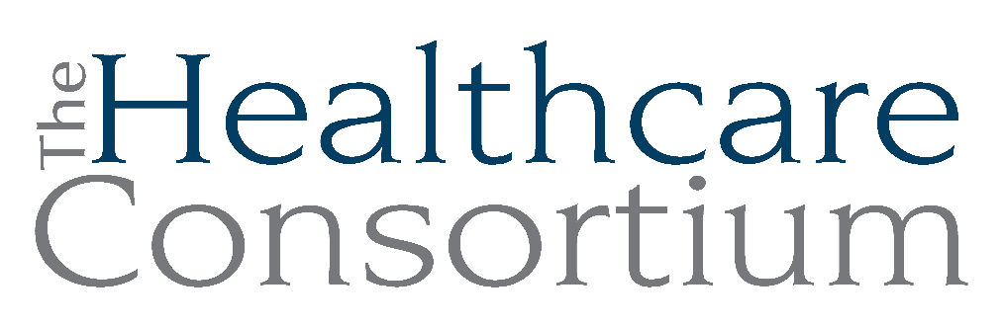

Notes from the Board of Directors Meeting of October 2, 2024

I. Call to Order and Roll Call
The meeting was called to order by President Becky Polmateer at 2:43 p.m.

The following members were present at roll call: Karen Amanna, Robin Andrews, Nina Benvenuto, Toni Carroll, Bob Gibson, Theresa Lux, Victoria McGahan, Maria Ostrander, Amanda Pierro, Becky Polmateer, Aislinn Smith, and John Thompson.

The following members were absent from roll call: Dan Almasi, PJ Keeler, Jack Mabb, Marielle McKasty-Stagg, Art Proper, Jolene Race, David Rossetti, Scott Thomas, Dorothy Urschel, and Kathleen Eldridge.

Also present were staff members Claire Parde and Lisa Thomas.

II. Service Story
Prompted by the Governance Committee, Service Stories are brief anecdotes that are meant to illustrate the nature of work and its impact on our clients. Claire presented a story written by Nathan McLaughlin, Director of Consumer Assistance Programs:

“We recently had a walk-in client who reported being charged $700 for an important behavioral health medication. He met with a Navigator but lacked enough information for us to resolve the problem in that first visit. Later that same day, his representative payee arrived with paperwork that helped us determine that the individual had been enrolled in both Medicare and Medicaid but the situation suggested that his Medicaid had lapsed. Since his dual enrollment status would necessitate working with DSS, we decided that the client would be best served by engaging with staff from both our Navigator Program and NYConnects. During the client’s next scheduled appointment, we were able to conference call with DSS to determine his status; thereafter, our Navigator was able to reactivate his Medicaid that very same day. We anticipate that we will continue to be engaged with this client, who would benefit from a referral to local mental health treatment, help identifying a local doctor, and a connection to a supported residential program.

This is an example of a client who was in the throes of substance abuse and mental health struggles while being caught up in a difficult and tense family situation, and who could easily fall between the cracks due to those issues. When people fall between those cracks, they lose access to medication, precipitating more problems; in this person's case, they have a history of financial crime and dangerous behavior. Our goal was to get him insurance as quickly as possible to prevent such a crisis from unfolding, and then dig deeper for solutions to the larger problems once the situation was stable. This first step of the solution shows how welcoming the Consortium can be to people of all walks of life, how effective our team can be when we coordinate our efforts, and how we can leverage the relationships we have with our partners on our client’s behalf.”

Claire shared another story that involves a partner agency, the Columbia County Office for the Aging. Claire received a call from a staff member of CARTS alerting her that our only wheelchair-accessible vehicle had broken down on the Berkshire Spur with a client and his companion aboard. Claire reached out to Nina Benvenuto, who didn’t hesitate to help. She personally drove OFA’s minibus to meet our bus and clients, now on a tow truck, and transport them safely home. Claire doesn’t know what we would have done if Nina didn’t come to our rescue. Karen and Aislinn both offered assistance from COARC and Pine Haven, respectively, if this should happen again.

III. Reminder of the Duty to Disclose
Becky reminded the group to please remember their duty to disclose any interests that may give rise to a conflict when the Board acts. Theresa Lux shared that the RHNDP grant application has been released, and she will be the primary writer for the Greene County Rural Health Network. Knowing that the grant is competitive, and Claire will be applying on behalf of the Consortium, Theresa thought it wise to disclose.

IV. Consent Agenda
The Board considered the following meeting minutes:
- Board of Directors meeting of August 7, 2024
- Budget and Finance Committee Meeting of September 24, 2024

The motion to accept the minutes/actions of the Board of Directors meeting of August 7, 2024 and the Budget and Finance Committee meeting minutes from September 24, 2024 was made by Bob Gibson, seconded by Robin Andrews, and unanimously approved.

V. Treasurer’s Report
A. Fiscal Highlights Report
On behalf of Board Treasurer, Jack Mabb, Claire presented the Fiscal Highlights Report. The cash balance is good. We continue to split cash between the Bank of Greene County and Live Oak Bank. We are earning a minimum of $700.00 per month in interest. The investment account is also performing well. TJ Pellitteri from North Country Financial Group meets with the Budget and Finance Committee bimonthly and oversees the 401(k) for staff. He will present at the staff meeting in December and will be available to meet individually with staff if they so choose.

B. Seeking approval for the updated 2024 Annual Operating Budget
The annual operating budget was created last Fall with the assumption that we would continue the Tobacco Program. When the decision was made to forego applying for the next contract, we pledged to update the 2024 operating budget to account for that change. We have done so and presented it at the last Budget and Finance Committee meeting. We are now seeking approval from the full Board.

The motion to approve the updated 2024 Annual Operating Budget was made by Theresa Lux, seconded by Bob Gibson, and unanimously approved.

C. Update on preparation of the IRS 990

We have received the IRS 990 (federal tax filing), but there are errors. We are making a list to send to the Bonadio Group. It is expected to be completed in the next couple of weeks. It will be circulated to all Board members for review and comment. It must be filed by November 15th.

Claire plans to issue a request for bids from auditing firms.

VI. President’s Report
- Strategic Planning Update
Board President Becky Polmateer provided an update on strategic planning. The Committee has met two times and has worked through the SWOT process. They are meeting projected dates and will have a presentation ready for the full Board in December.

- Annual ED Performance Evaluation Process
Claire’s annual evaluation survey is being drafted and will be distributed soon. Board members will be asked to respond to the Executive Committee by the first Wednesday in November, in time for the next Executive Committee meeting on November 6th. Answers will be anonymous.

Note that Claire’s current contract is for two years, ending December 31, 2025. Therefore, decisions by the Board regarding compensation are not required this year.

VII. Executive Director’s Report
- Highlights from/questions about the written ED’s report
The Consortium applied to be part of the Social Care Network with Healthy Alliance. Deliverables, such as screenings and enhanced Navigator services, will begin January 1, 2025. This type of work would seem to complement our existing work and staff skill sets but as details about what will be expected of us are very vague right now, we will need to see if we can actually perform the necessary tasks. Catholic Charities also applied and will wait to see what this entails. We expect that ultimately there will be multiple partners in each community and plenty of work to go around.

We hired Greg Pettyjohn, who is the new Director of Finance. He comes from the Columbia County Historical Society, which has a smaller and less complex revenue picture than we do, so there is a learning curve. John Ray is training him, and Claire will get feedback from John on Greg’s progress. John will be available to us after he retires, but we don’t know for how long.

Our new Navigator, Peter Destyl, should be certified by NYS by the end of the week. We interviewed another candidate for Navigator today. We used to have a steady workforce in Navigator. We now have turnover. It is our most entry level position.

Our Fall Newsletter was distributed via email on Monday, September 30th.

The first-ever “Charity Night @ Night School” will benefit the Healthcare Consortium. It is scheduled for Thursday, October 10th from 5:00 to 8:00 p.m. in Athens.

VIII. Network Member Spotlight―PINE HAVEN
Board colleague and host, Aislinn Smith, provided an overview of Pine Haven Nursing and Rehabilitation Center.
- Their meeting area is always available. They have a pavilion as well.
- Pine Haven is a skilled nursing facility with 120 beds. They have short-term rehab. with 40 beds and two long-term units. They cohabitate populations. It’s like a community with a hair salon, religious services, etc. They also have events and will be having a Halloween party. The building is from the 1700s. It was a home for the poor.
- Pine Haven used to be a county building. The community was concerned with the transition, but it has been newly renovated. It’s clean with great staff and nursing without a lot of turnover. The management team leads by example and has changed the culture for the better. Staff with little to no experience have been hired as they bring hope and don’t have preconceived ideas. It has brought energy.
- The focus is on the individual and being person-centered. Family dynamics is the biggest issue.
- Trust is also a problem because people have ideas about nursing homes that aren’t always positive. Pine Haven isn’t perfect, but they are stable and improving every day. Nursing homes aren’t places to fear.
- Star ratings are misleading because one incident can cause a poor rating even if it isn’t the facility’s fault. Lack of surveys can also decrease the rating. There have only been three since 2017. They expect a survey soon and expect the rating to go up. No facility in Columbia County is above a three-star rating. Smaller facilities are at a disadvantage.
- There is a waiting list for long-term beds. The census has been good lately.
- Pine Haven’s sister agency in Greene County is Green Meadows. They have the same owner but are two separate entities.
- Bob Gibson shared that he appreciates the partnership with Pine Haven. He is very pleased with the interaction and care provided to clients. It is a good facility.
- The corporation that owns Pine Haven is present in Western NY, Pennsylvania, New Jersey and Florida. They look for buildings that are failing or struggling.
- Medicaid is the primary payor.
- 85% of admissions don’t look at the facility first.

IX. Adjournment
The business of the regular Board meeting being concluded, the meeting was adjourned at 4:05 p.m.

Respectfully submitted,

Robin Andrews, Board Secretary

