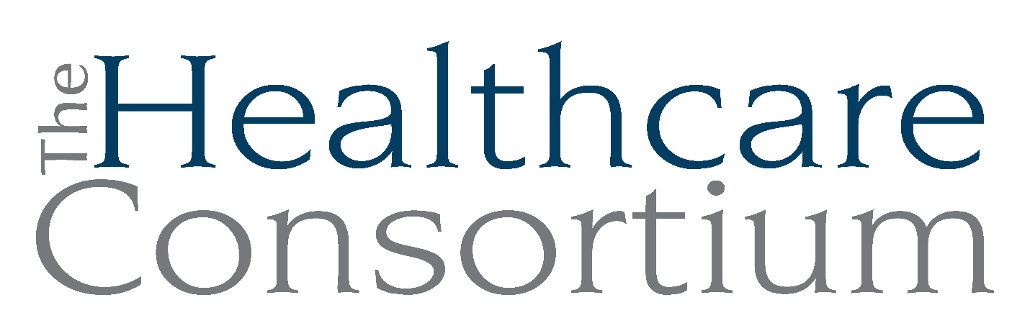
ED’s Year-End Report to the Board
December 4, 2024

UPDATES

Bad news:
- The Foundation for Community Health determined that we are no longer eligible to apply for General Operating Support, due to the limited overlap of our respective service areas; they will continue to provide program support targeted to the Towns of Copake and Ancram

Good news:
- Payment of $74,802 from Columbia County for NYConnects’ April to September vouchers
- Granted $50,000 for CARTS from the HRBT Foundation, half granted now and the other half in April 2025; we’ll be eligible to apply again in April 2026
- $125,000 from the Mother Cabrini Health Foundation

REFLECTIONS on the past year

Program Management
The biggest program management decision we made this year was the one related to our ongoing involvement in Tobacco Control work.
Separate but related is the management of that program during its “runout” phase—that is, the several months between the moment in early part of the year when we decided not to pursue the next contract and when the current contract ended on June 30th. Managed runout phase with an experienced consultant to provide program management and staff direction.

Staffing
Reorganization of the administrative team
- 1.0 FTE Executive Director
- 1.0 FTE Director of Finance
- 1.0 FTE Director of Business Operations
- .6 FTE Director of Development and Communications
With the new Director of Programs and Transportation Program Director, this group constitutes the Leadership Team.

Staffing program positions
There’s been considerable activity in Navigator:
- Fired Bonnie Snyder
- Retired Elaine Allen
- Hired Emi Davenport
- Hired, trained and fired Peter Destyl
- Hired David Leacock
Throughout, Navigator Program Coordinator Doreen Rodriguez has been a stalwart, welcoming, training, and launching the new team members with competence and aplomb.
We also created and filled a CARTS Program Assistant role, which is a third member of the program support staff.

Development and Communications
Development:
- Licensing a donor database, Bloomerang
- Annual Recognition Event
- CARTS Fundraiser
- Night School Friendraiser
- EOY campaign with new donor envelope

Communications:
- FB business page established
- Instagram account established
- LinkedIn account established
- Created a seasonal newsletter
- Secured a “Certificate of Assumed Name” as “The Healthcare Consortium”
- Updated logo, brochure, business cards, tablecloths, mugs, pens
- Redesigned annual impact report
- Created new donation flyers and envelopes
- Created New Client Welcome Packet

Board/Network Relationships
We grew the Network, adding two new members:
• Columbia County Recovery Kitchen
• Pine Haven Nursing and Rehabilitation Center

We also recruited, onboarded, oriented, and supported four new board members:
• Nina Benvenuto
• Karen Amanna
• Jolene Race
• Aislinn Smith

Strategic Planning
- Developed three-year strategic plan with committee of the board

FORECASTING the year ahead
- Paying close attention and providing guidance and oversight to the new Director of Finance
- Figuring out how the Director of Business Operations can support Fiscal
- Ongoing attention to staffing in the Navigator Program, NYConnects as well
- Ongoing attention to fundraising, including donor development
- Pursuit of support for new business; we’ll be trying to secure a NYS contract to support new work that complements our program portfolio

